How I spent my summer holidays

Summer is children’s favorite season. Summer is the best season for rest because it is warm ,the nature is beautiful and we have grate opportunities for relaxing. We can go for a walk ,play different games ,go to the seaside or to the mountains and so on.
As for me ,I like summer too. These holidays were exciting and very interesting. At the end of school year I passed all my exams with excellent marks and after that my family and I went abroad. We went to Germany by airplane to visit our grandparents. We stayed there for three months. During this time we visited a lot of interesting places. The most exciting excursion was to the Alps. My granny and I visited Neuschwanstein Castle and Königssee Lake.
I’d like to say some words about the castle because it impressed me a lot. This castle was built in 19th century by Ludwig the 2nd of Bavaria. This palace is so beautiful that it became the inspiration for Disneyland’s Sleeping Beauty Castle. There were crowds of tourists from all over the world especially from Japan and Russia. I made friends with German teenagers and now we get in touch from time to time. 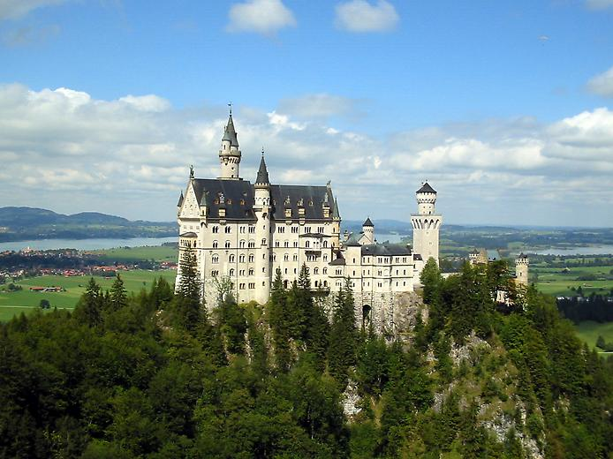

Also I spent wonderful time at Königssee Lake. It is the cleanest lake in Germany with very picturesque land scape. Only electric-powered passenger ships ,rowing and pedal boats have been permitted on the lake since 1909 ,because the Germans protect their beautiful and clear nature. 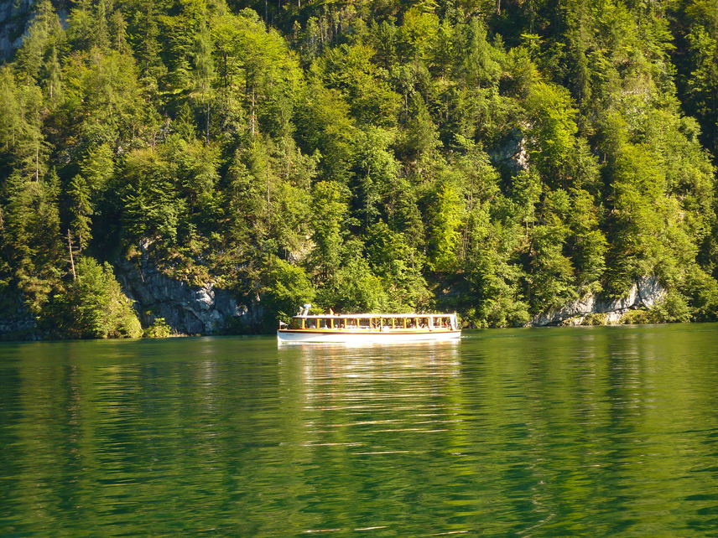
In conclusion I’d like to say that summer holidays are the perfect time for travelling and getting new experience. I spent marvelous time having fun ,visiting unusual places ,meeting interesting people and practicing my English and German. I will remember this time and I look forward to new adventures.
