“My Summer Adventure”
Автор: ученица 5 -а_класса Смирнова Наталья.
Учитель: Медведкова Юлия Сергеевна
Школа: МБОУ «ООШ № 100 им. С. Е. Цветкова»
Населенный пункт: г. Новокузнецк
Регион: Кемеровская область

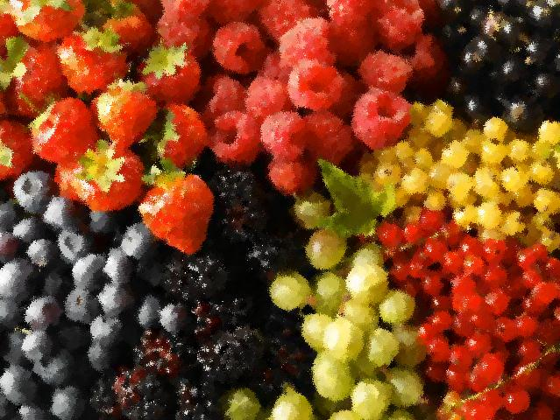
This summer I was at my grandmother’s dacha in Karlyk and in Sheregesh at my other grandmother and we visited Altai. I liked very much at the dacha because there I have many friends. I went for a ride on a bicycle with them, swung on a tarzanka and on a swing, swam in the river and helped the grandmother with the garden. I liked in Sheregesh too. There is also a dacha with the garden. Also we went to Tashtagol. It is very beautiful there. We were in a park where on a small hill there is a statue of a big and beautiful elk on which a girl sits. Then we went to Altai. Our relatives from Sheregesh also went with us, and we went by two cars. On the way to Altai we stopped in Novosibirsk where we spent the night and visited a big Novosibirsk zoo. There are a lot of different animals, but I most of all liked small funny monkeys who played, fought, hung on their tails and asked berries of a mountain ash which grow in the same park. The next city where we stopped was the Stone - on - Ob. There we spent the night in hotel near the river. In the morning we went to an amusement park where we walked and went for a ride on a big wheel. Then we swam in the river, only not for so long because we needed to go further. After several hours of driving we came to the town Yarovoe in Altai. We arrived in the evening. We were very tired and didn't have time to look at the town. Next day we swam, and in the evening we walked in the park, where there are a lot of statues of Hamlet. All of them are different, unusual and interesting. On the way back we stopped in the Peshcherka falls. I liked it there very much too. So I had a very interesting summer.

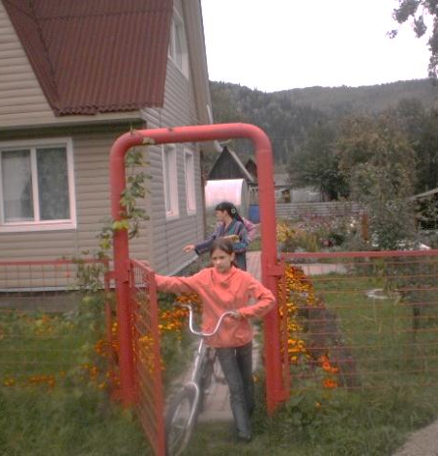

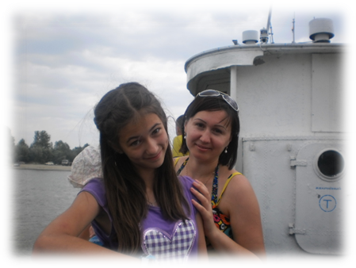

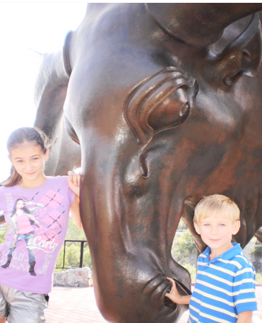

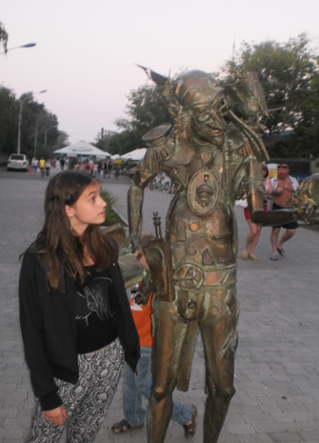

Использованные ресурсы:
- Фотографии взяты из семейного архива автора и размещены с разрешения родителей.
- http://www.geo.fr/var/geo/storage/images/media/images/rubrique-environnement/actualite-durable/fruits/405328-1-fre-FR/fruits_940x705.jpg
- http://www.goodfon.ru/download.php?id=8808&rash=1600x900
- http://fotki.yandex.ru/users/ir-evteeva/view/468254/?page=156
- http://fotki.yandex.ru/users/ya-semira/view/484934/?page=0
- http://fotki.yandex.ru/users/lady-annadu/view/424061/?page=0
- http://fotki.yandex.ru/users/k-tiande/view/488086/?page=4
- http://baby-best.ru/uploads/_ld/91/82905.jpg

