“My Summer Adventure”

Автор: ученица 8–а класса Потехина Александра.
Учитель: Медведкова Юлия Сергеевна
Школа: МБОУ «ООШ № 100 им. С. Е. Цветкова»
Населенный пункт: г. Новокузнецк
Регион: Кемеровская область.

There came long-awaited June. We packed our bags and flew to the Kingdom of Thailand. Our plane landed at the airport in Bangkok. Airport impressed me with its size, it was very huge. There were a large number of people and all spoke different languages. Here we can see large groups of Japanese, German, Chinese, English, Russian and many other inhabitants of the earth.
We took a bus and went to the hotel «Sea Breeze jomtien resort». Our hotel was in the city of Pattaya. On the way to the hotel I was surprised by a huge number of motorbikes, which I saw in the window of the bus. Finally we got to the hotel, where we were met with good-natured Thais.
While parents are unpacking, I ran to swim to the pool. In the evening we went for a walk around town and see the Gulf of Thailand. Next day we accustomed, visited several cozy cafes where then had lunch and dinner. Some Thai people know Russian, but most speak with Russians in English; school language skills were useful to me.
During our stay in Thailand we visited a lot of excursions. The most memorable visit was to the «Discovery». The guide immediately warned that we can take food for the animals. We bought bananas and green beans. The first to be fed from the hand were deer. The feeling was magnificent. Then we fed hippos, from the bridge to their mouths we threw beans and bananas. When we came to the paddock with rhinos, to surprise there was no limit. The rhinoceros that from the screen of the TV seemed very hostile actually appeared a lovely animal that we ironed, held for its horn and fed.
Nature is very beautiful: palm trees, flowers, banana trees, beds with pineapples.
And I learned and saw that a giraffe’s tongue is 45 cm and they like beans. We were overwhelmed with emotions.
Thailand is very exotic country. Two weeks passed like a day. It's time to go home. Tears were in my eyes, but I know that I will come back here. I really enjoyed being here.
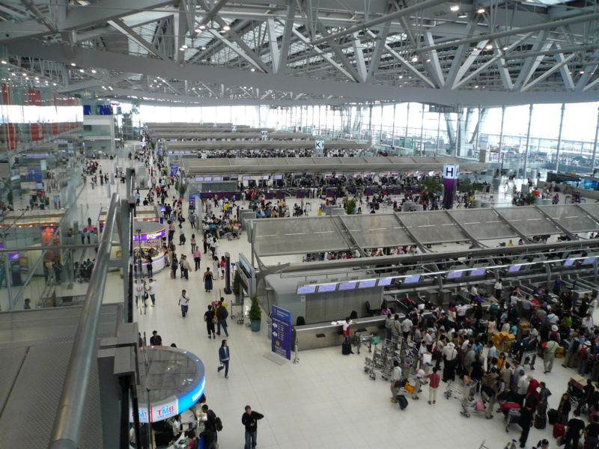

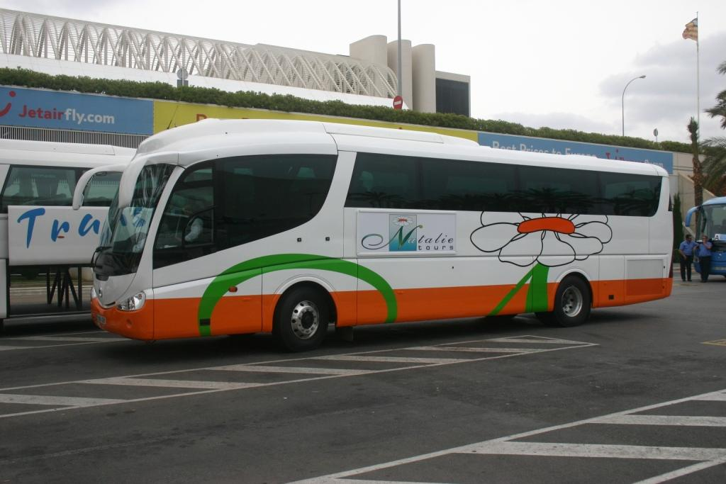
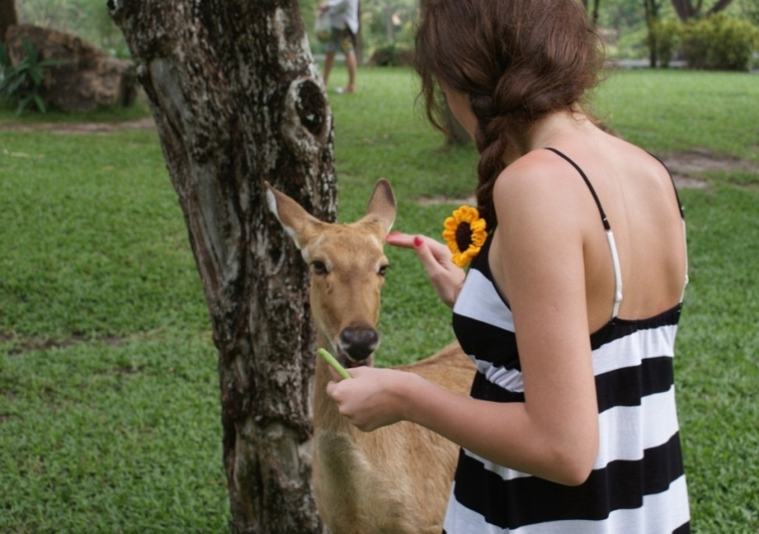

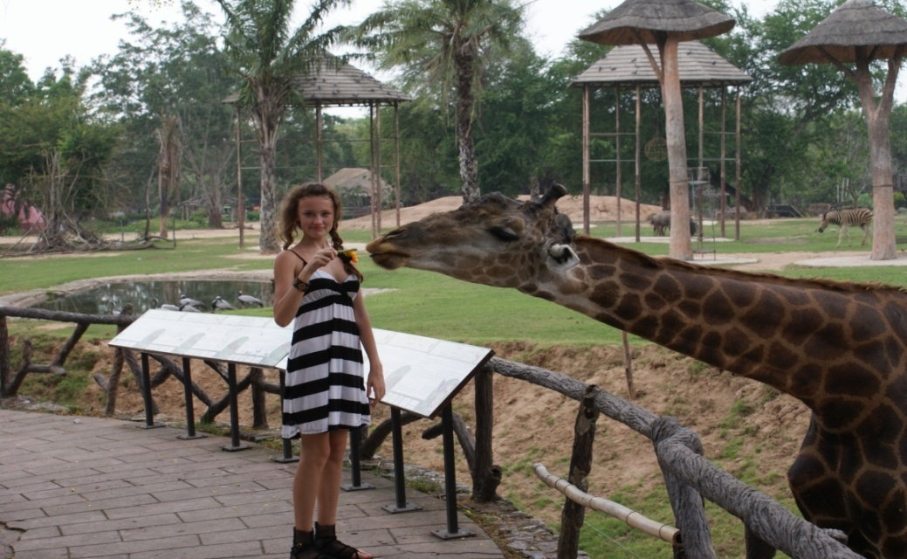

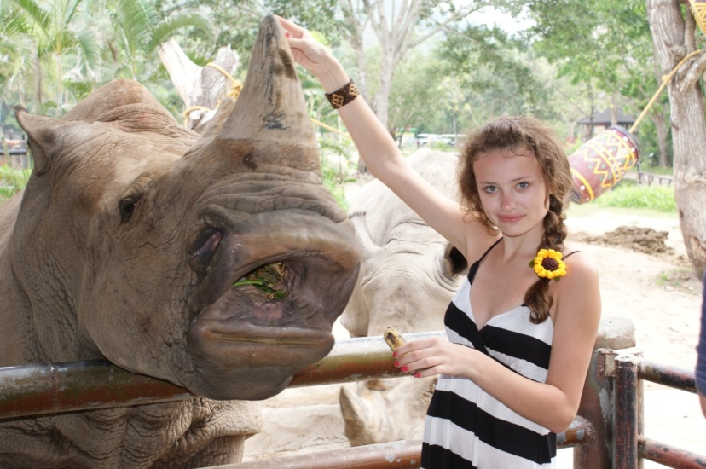

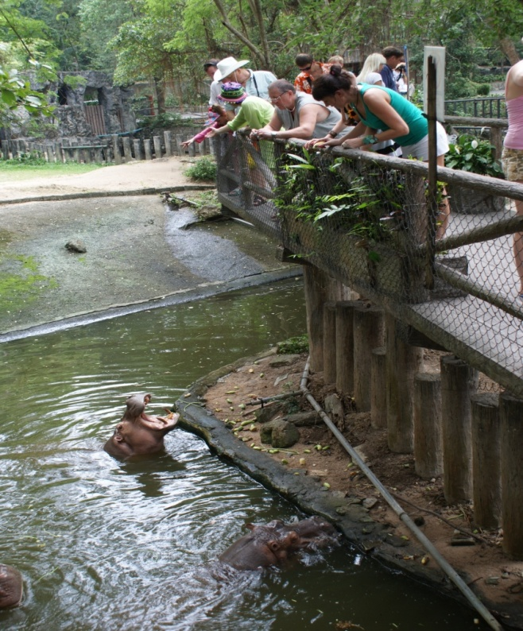

S.

Использованные ресурсы:
1. http://www.gdefon.ru/download/nebo_solnce_oblaka_fon/436/1600x1200
2.Фотографии взяты из семейного архива автора и размещены с разрешения родителей.

