I have been always looking forward to my summer holidays. As you know, it is the most exciting time of children’s life .We can relax as much as we can splashing in the warm sea, rollerskating and travelling. In my opinion, there is nothing like going somewhere for a change. If I were older I would travel all over the world. You see, everybody deserves a good rest after a good deal of work .So, being encouraged by the proverb “Work , work and no rest makes Jack a dull boy” I made up my mind to have a really good holiday.

“My Summer Adventure”

Автор: ученица 8Б класса Синяева Елена
Учитель: Синяева Людмила Николаевна
Школа: ЧОУ «Гимназия № 1»
Населенный пункт: г. Новороссийск
Регион: Краснодарский край

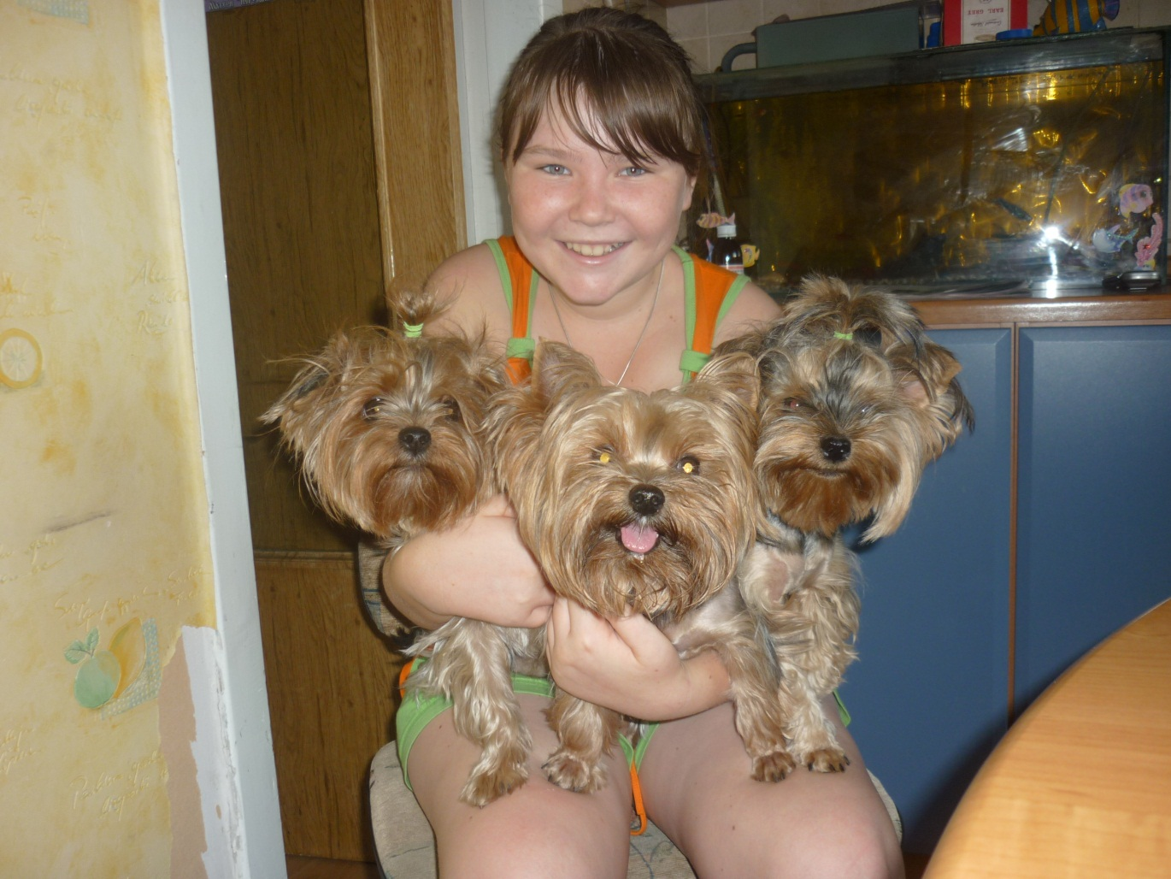

.
I have been always looking forward to my summer holidays. As you know, it is the most exciting time of children’s life .We can relax as much as we can splashing in the warm sea, rollerskating and travelling. In my opinion, there is nothing like going somewhere for a change. If I were older I would travel all over the world. You see, everybody deserves a good rest after a good deal of work .So, being encouraged by the proverb “Work , work and no rest makes Jack a dull boy” I made up my mind to have a really good holiday.

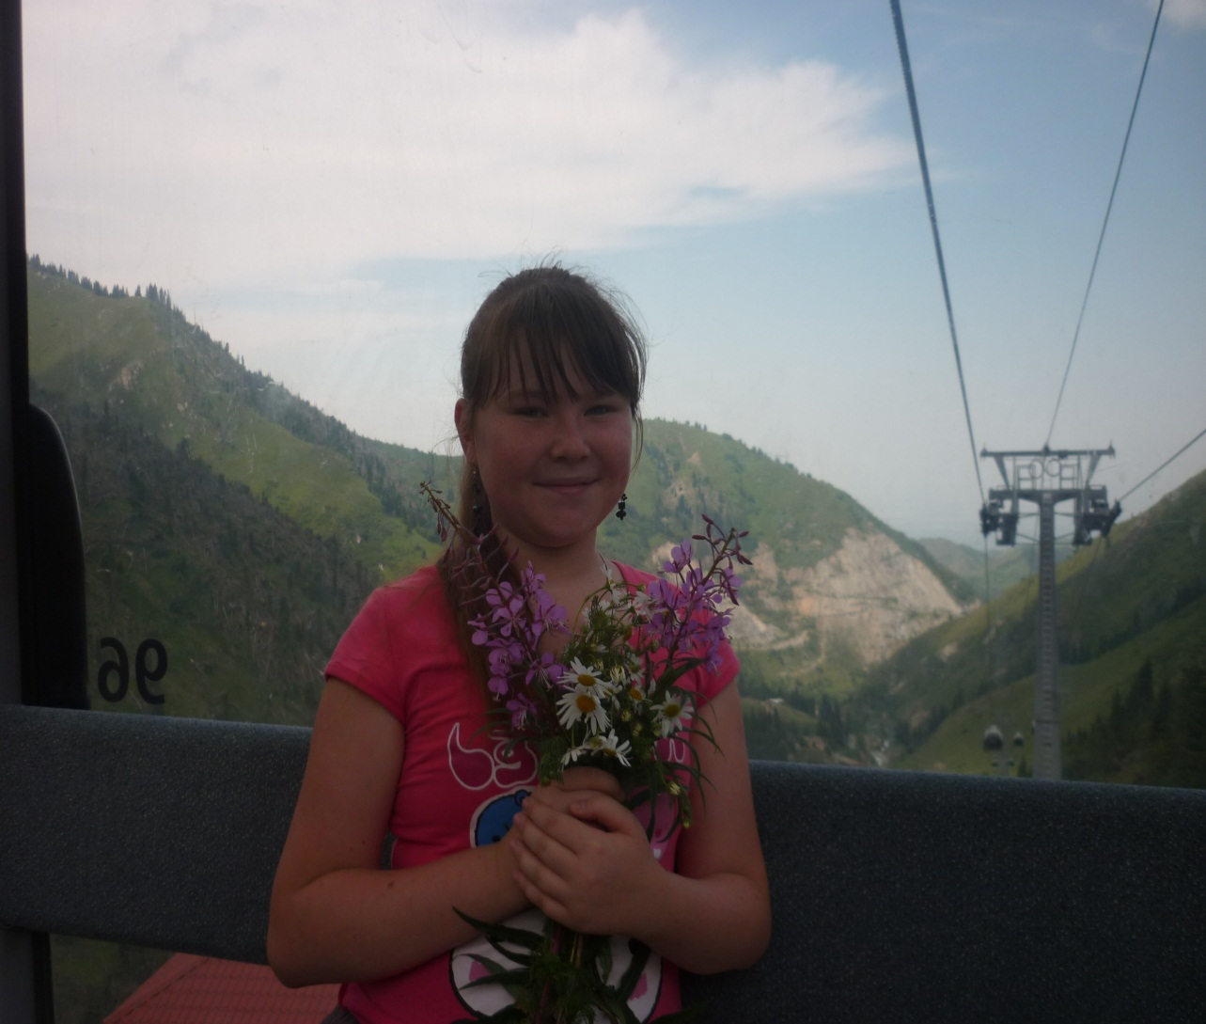

Last summer I had a good chance to go to Malta to master my English .I wanted it to become more fluent. My mummy saved enough money for my trip there .My friends told it is a very picturesque island in spring when flowers are in full blossom, but it is very hot there in summer .Nevertheless I have never been abroad and it would be nice to go somewhere in summer. But things got worth. There were some financial problems and the chance to join the group to Malta was lost.

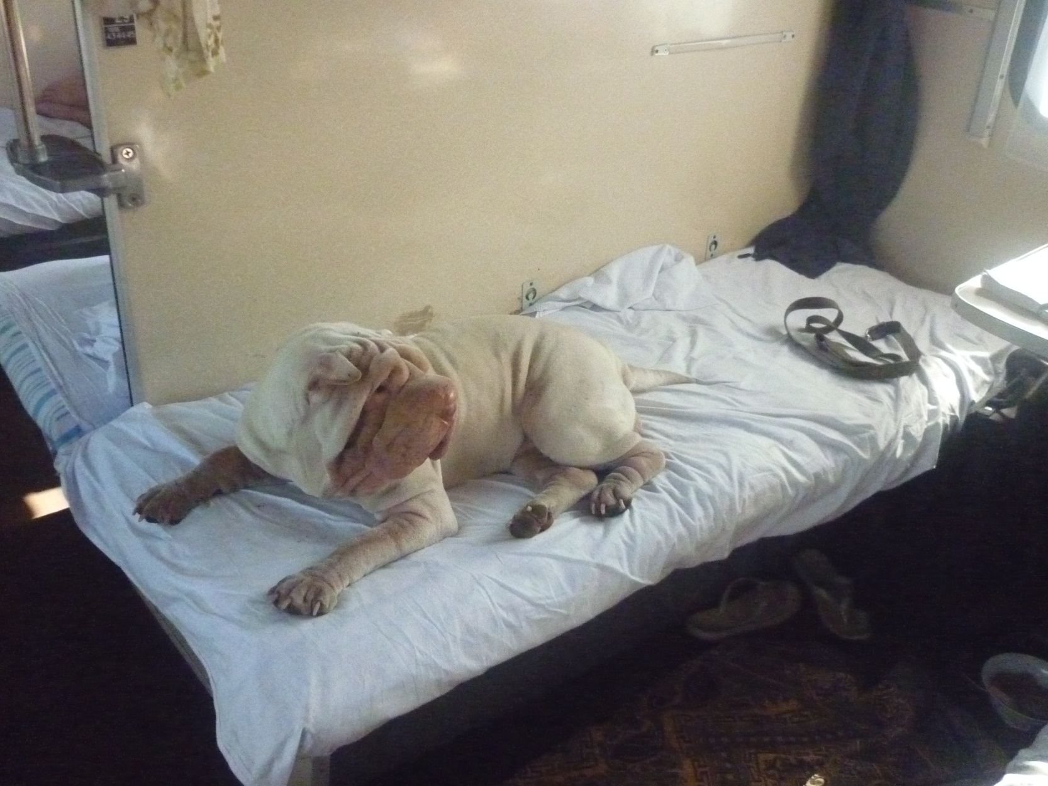

But, as you know “Every black cloud has a silver lining”. My granny decided to visit our relatives in Kasakhstan and I was happy to join her company. It took us five days to get there by train. Frankly speaking, our journey was tiring ,but unforgettable. We saw various places through the window of the train, spoke to different people we met. I’ d like to tell about the most interesting moment of our journey by train .One of our passengers was a dog whose master bought the ticket especially for his pet! It was so unusual! The dog enjoyed our company. He wagged his tail all the time greeting everybody in the compartment.
It was my first trip without my mother. I missed her very much.

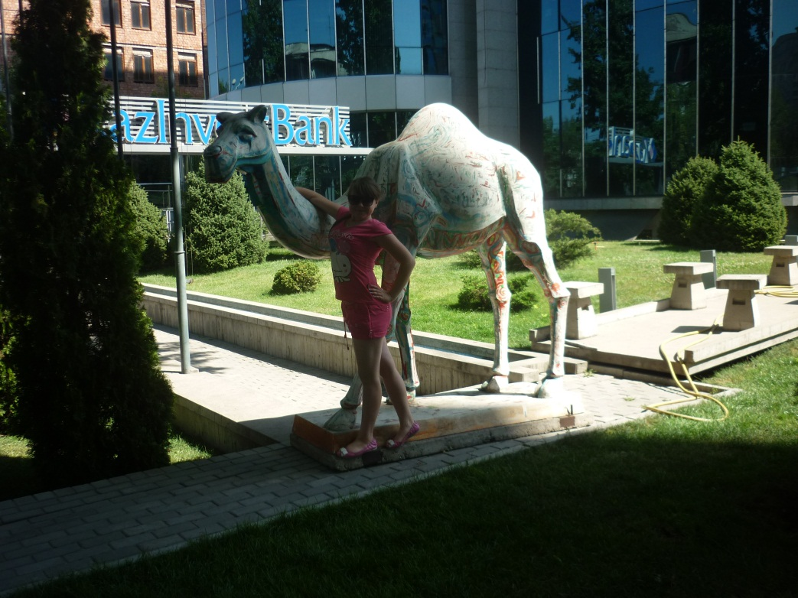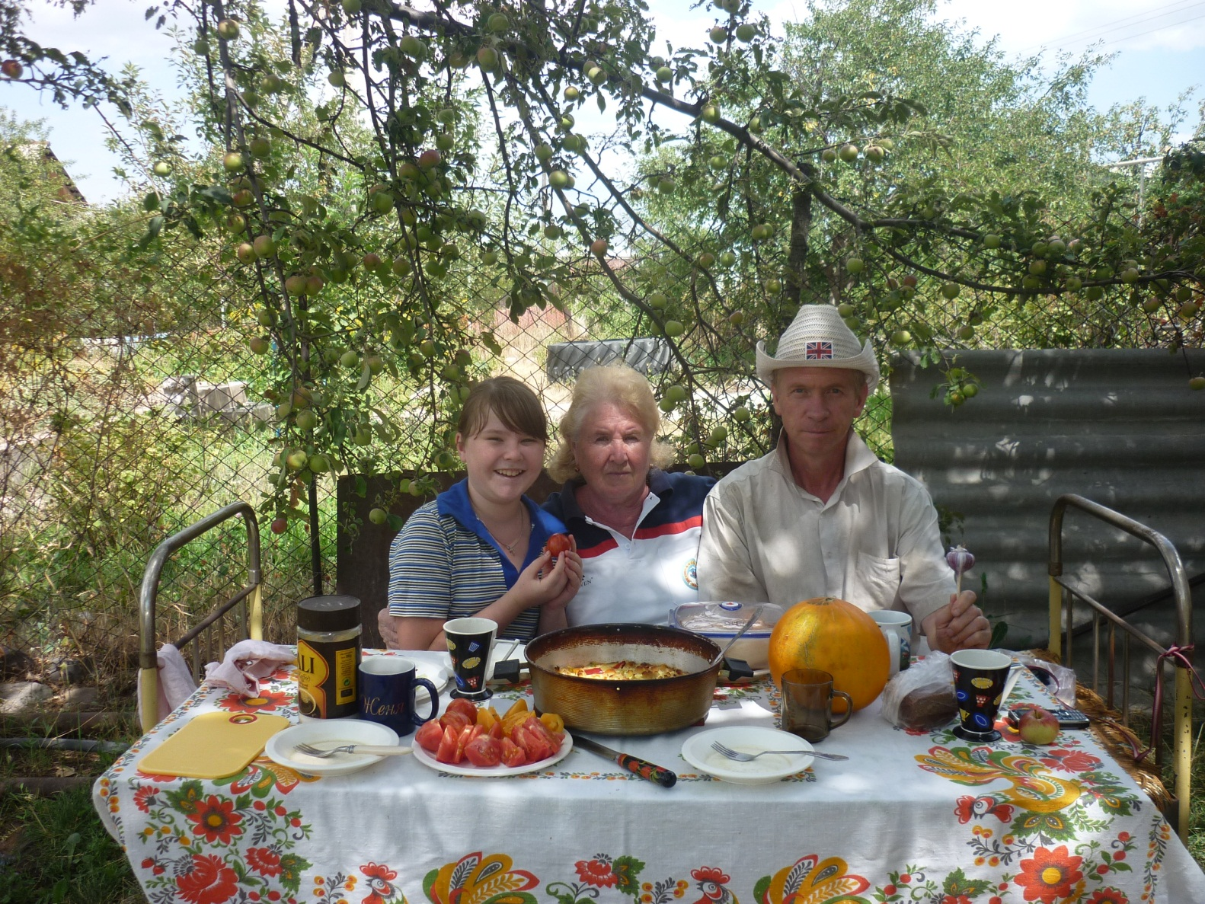
But nevertheless I was happy to see something new. So I was impressed by the former capital of this country. It is the city of Almaty. This city is well equipped to meet every need of the tourists with various hotels , but we stayed at our relatives. They are nice and sociable people. Aunt Nina is a nurse, uncle Pavel is a building engineer. He likes to drive a car and he is really an excellent driver.

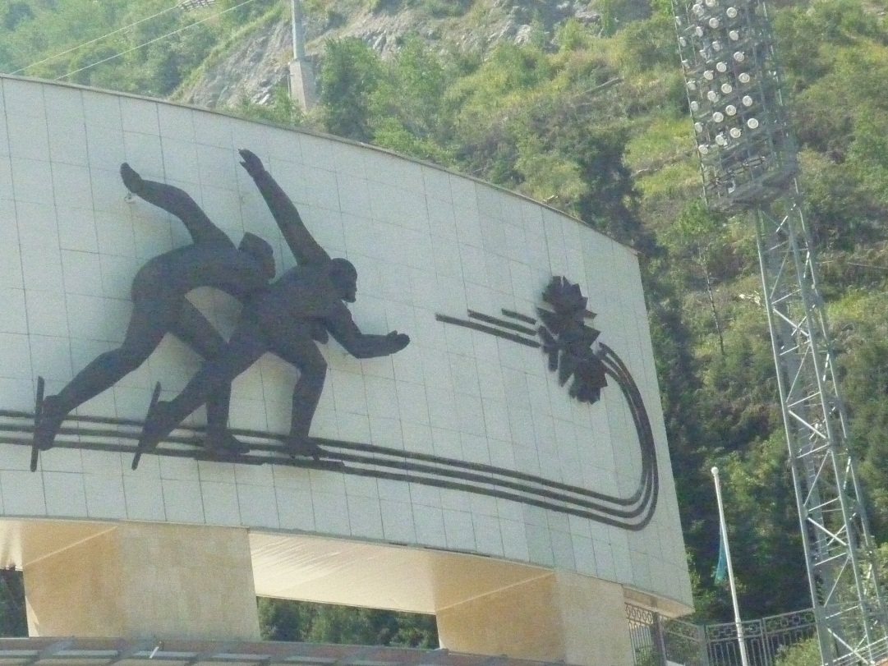

One day he rented a car and invited us for a ride. It was a really delightful trip. After our car was parked we climbed the mountain оn the rope road and saw one of the most beautiful skating rinks of the world .It was Medeo. It looked like an ocean covered with a thick sheet of ice. It was summer, so the skating rink was closed. We were not allowed to go inside. But on our way back we were surprised by the picturesque sight . The trees were mainly pines and fir-trees. Everything seemed to have emerald green colour. But on our way further the trees lay broken and crooked. The wind seemed to have made fun of them. It was a real disaster. In fact, nobody wanted such situation to repeat again. I wished we reached the top of the mountain Chumbulak, but it was too cold there and my clothes were too light. Nevertheless I really enjoyed my trip and would like to repeat it again. Besides, I hope someday to go to Malta!!!
http://900igr.net/photo/tsvet-i-forma/TSveta-3.files/018-Goluboj-tsvet.html.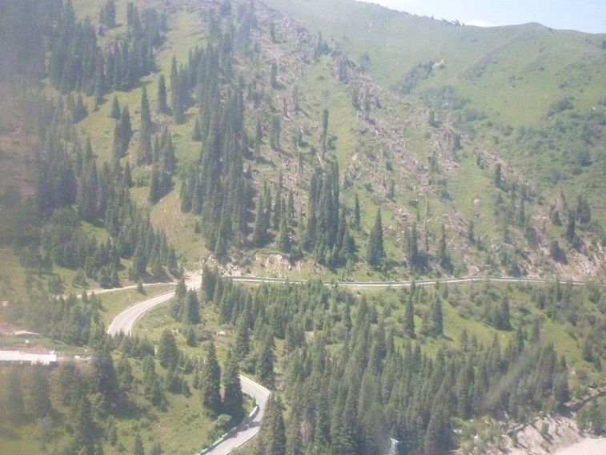
Фото из личного архива семьи Синяевых. Публикуются с разрешения родителей несовершеннолетнего.

