“My summer adventure”

Автор: ученик 7Б класса Бадрутдинов Эмиль
Учитель: Хусаинова Гульфия Замиловна
Школа: МАОУ СОШ №2
Населённый пункт: г. Лениногорск
Регион: Республика Татарстан

I’d like to tell you about my last summer holidays.
First, I went to the camp ‘Landysh’. I spent eighteen days there. There is a water pool in camp. The weather was hot and we swam and sunbathed there. In the evenings we went to disco and danced. There is a forest near the camp and we walked and picked flowers there. We made a fire in the woods, sang songs and played games. I had a nice time in the camp.

Then July came and I went to the village to visit my grandparents. There is nothing like our village. I helped my granddad to build a garage, worked in the garden and fed cattle.
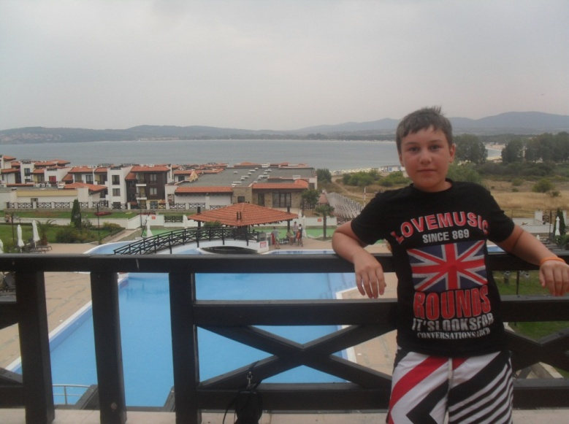
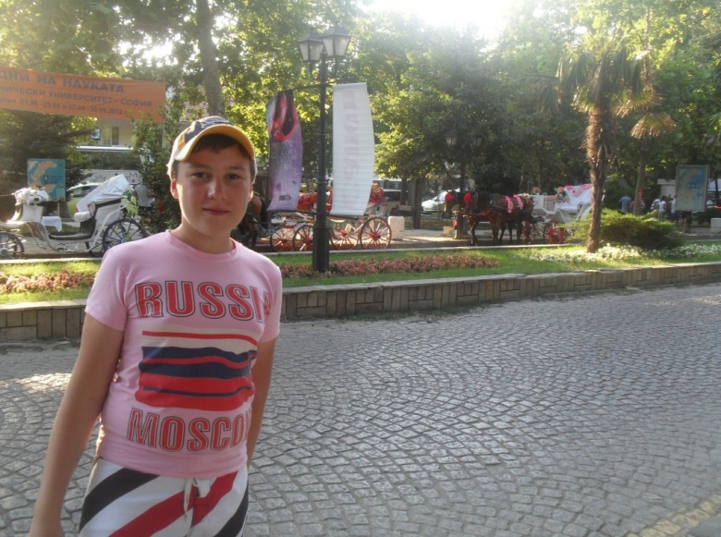
In August I made a trip to Bulgaria with my uncle and little brother. We lived in the countryside in my uncle’s house. There is the Black sea not far from his house. We swam a lot, walked along the beach and visited restaurants. I think spending holidays at the seaside is a great rest. I’ve had lots of fun there and it was wonderful!
Now I’m looking forward to my next summer holidays.

Использованные фотографии:
1.Фотографии из личного архива Бадрутдинова Эмиля опубликованы с согласия родителей.
2.http://www.tatneft.ru/wps/wcm/connect/tatneft/social/detskiy_otdih/landish/

