“My Summer Adventure”
Автор: ученица 6-2 класса Анферова Анастасия
Учитель: Шкодина Наталья Владимировна
Школа: МАОУ «Лицей математики и информатики»
Населенный пункт: г. Саратов
Регион: Саратовская область

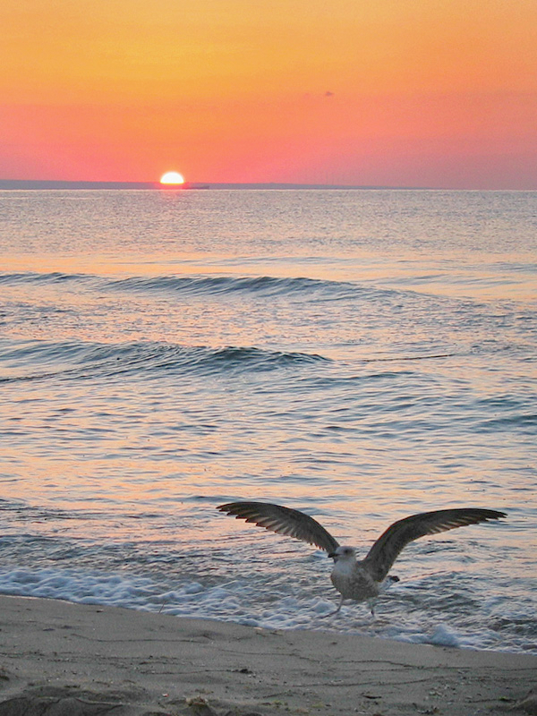
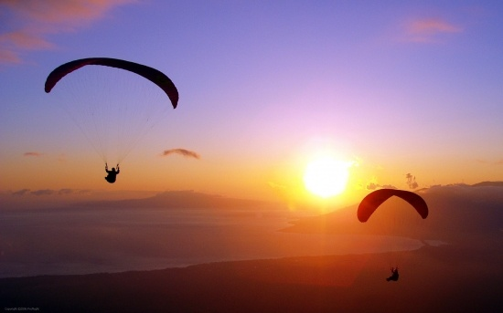
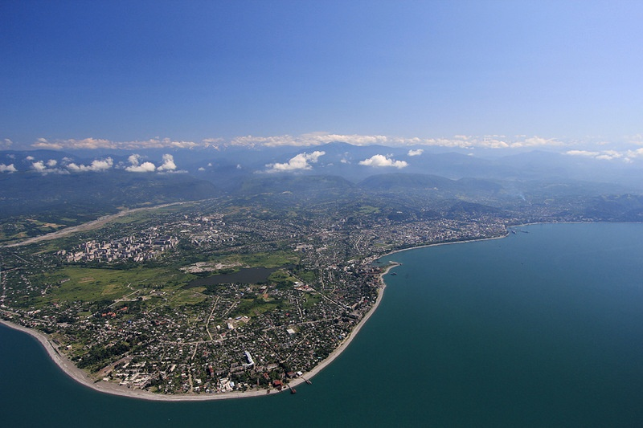
This summer was very busy and fun! My family and I went hiking, driving around with Overnight forest, we climbed the mountains! But it cannot be compared to what I want to tell you!
In August we decided to go to Abkhazia and really relaxed there. At first everything was calm and uninteresting... Then the idea to fly in a para-glider over the sea struck my mummy. Of course, we had special insurance equipment, but still the fear didn’t leave me.
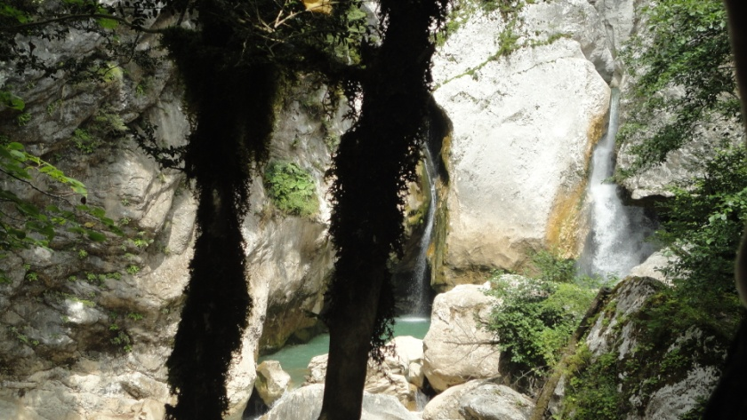
So the day came when all this was going to happen. All my thoughts were confused on the one hand, because I wanted to try, but on the other hand – that very Fear.
And here we are on the mountain, and the instructor provides a signal ... And we take off. I was flying the first few seconds with my eyes closed, but then cool gentle breeze touched my face, and my eyes opened. Everything was extraordinary beautiful. The view was fantastic: the fabulous mountains, the shining glassy surface of the water. Buildings that I could see were so small, they were all in a blur. What a beautiful view of the mountains! I just forgot about my fear. The whole flight seemed to last for an instant. I got an unforgettable impression.
Two days later we decided to go camping. We went to the mountains and our trip lasted for 5 days. It was very cool and fun! I took a lot of pictures. But all that time I had the picture that I saw when hovering in the air.
This is the story how I overcame my fear and I think it was not in vain! Thanks to this wonderful summer I realized that I do not have anything to be afraid of!

В работе использованы фотографии из личного архива автора.
Все фотографии опубликованы с согласия родителей несовершеннолетнего ребенка.

