My Summer Adventures

Автор: ученица 11 класса Монько Кристина
Учитель: Калинина Марина Валерьевна
Школа: МБОУ СОШ №5
Населенный пункт: г. Шахты
Регион: Ростовская область

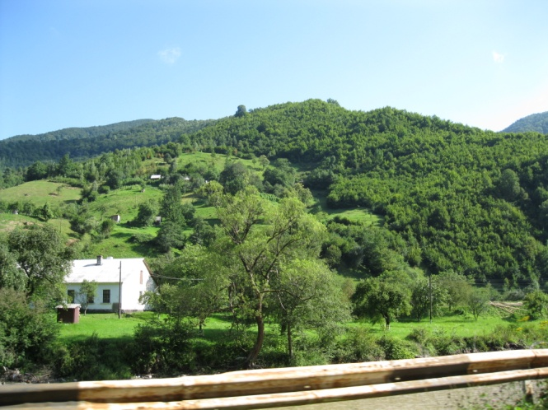
MY SUMMER ADVENTURE

I don`t dream about Maldives at all.
I don`t dream about Haiti at night.
Fashion islands… They aren’t my goal,
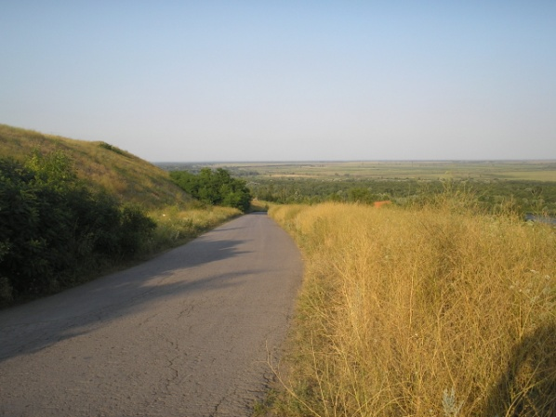
I`ve my own and different sight.

Our Russia – is beautiful space.
Our nature is splendid and great.
Every little and regular place
Has its majesty, face and state.

And that`s why I`ve decided to tell
You about our holiday trip.
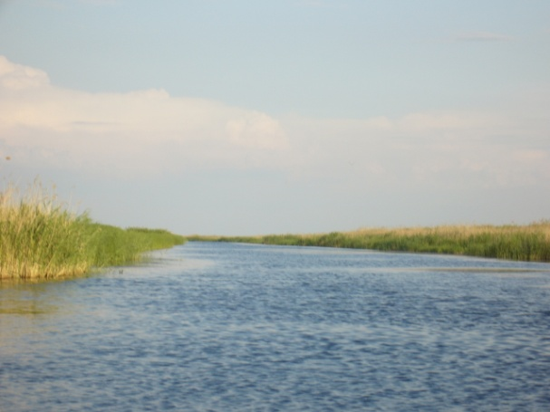
As for me, it was merry. Well
So let`s have on it moderate peep.

And in June I went to countryside.
From this moment I will begin.
Oh, it was like a peaceful bight
After city`s ado and din.
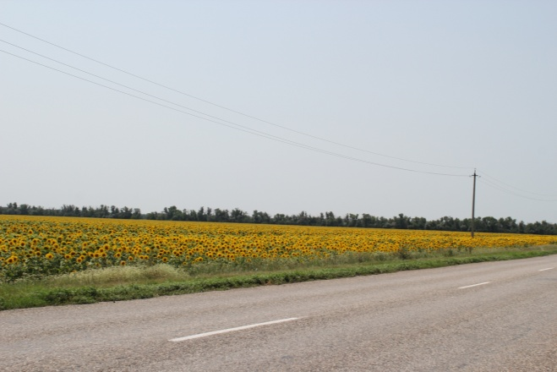
To be honest, I didn`t want
To go there at first at all.
Yes, it seemed to me like a bond,
Contradicted to my free soul.

And, of course, it was my mistake.
On the contrary, all was nice.
And it isn`t the cheat, or fake.
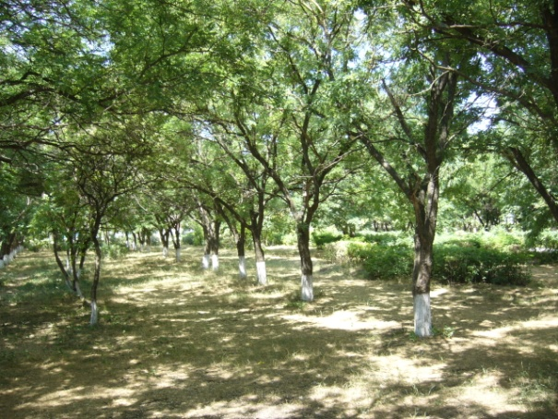
Meanwhile, I never tell the lies.

Their milk. For me it`s unique.
(Such important and famed detail!)
It will cure, if you are sick,
It will gladden, when you are hale.

Local people are queer. `Cause,
They`re astounding in their accord.
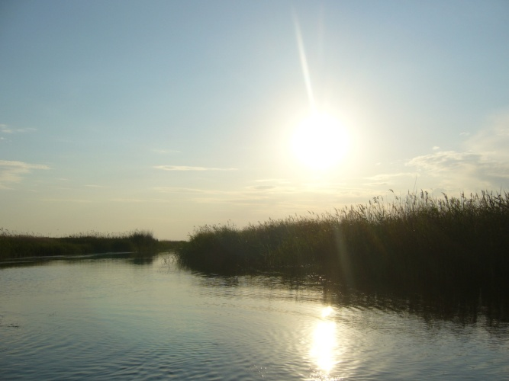
At first glance they are very close,
And don`t even you say a word.

In two days you won`t recognize,
All of them – they will be so loud!
They are gossipy. Even guys
Will tell you about village crowd.

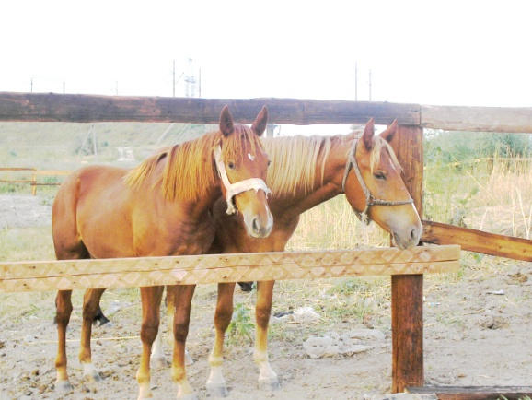
And I`ve fell in love with the fields,
Which surrounded me everywhere.
You will note that the nature heals
All your troubles if you just stare.

Those big shrubberies and the trees
Which are so wild, and lush, and old.
Give you calm and the real peace
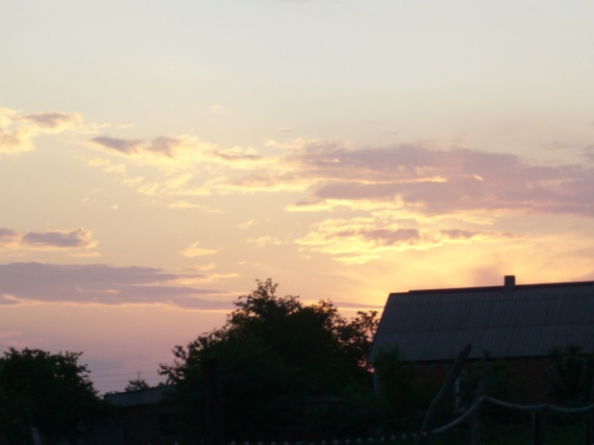
And make you so inspired and bold.

There was a large river too
With a picturesque pleasant shore.
Who will doubt its comeliness, who?
No one, I am convinced and sure.

Now I know how to ride a horse,
Those emotions I can`t explain.
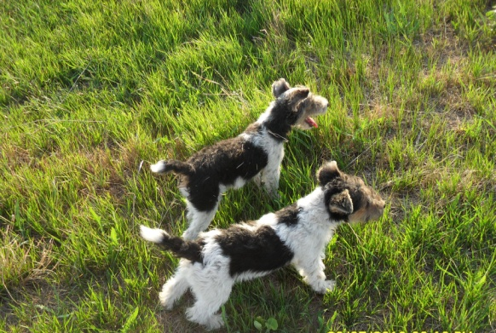
It is fearly a bit, of course,
But you want to do it again

And again… Although all your life.
It is really very great.
Doesn`t matter – you`re twenty-five,
Thirty-two or one hundred eight.
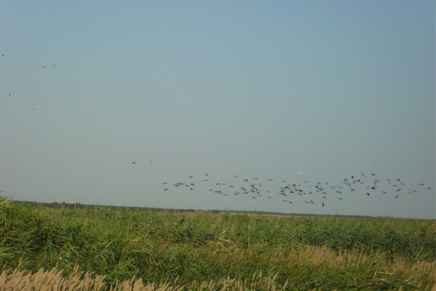

But I soon had to go away
From that blissful fantastic plot.
Even more, so, I craved to stay
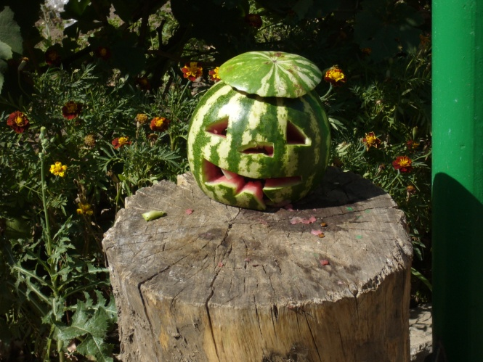
On that beautiful peaceful clot!

After that all of kin and I
With the friends went to torrid South
To amuse ourselves, to lie
Under rays and, of course, to bathe.
Just imagine this immense host
With a swarm of the crying kids.
I was totally there lost.
I believe every person needs

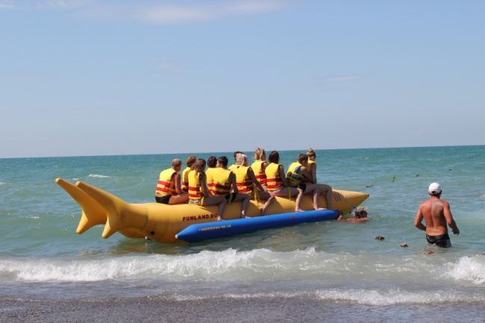
Sometimes silence and calm. You know
That uproar was dim to tell.
Oh, alas, I can`t here show
Every funny and droll detail.

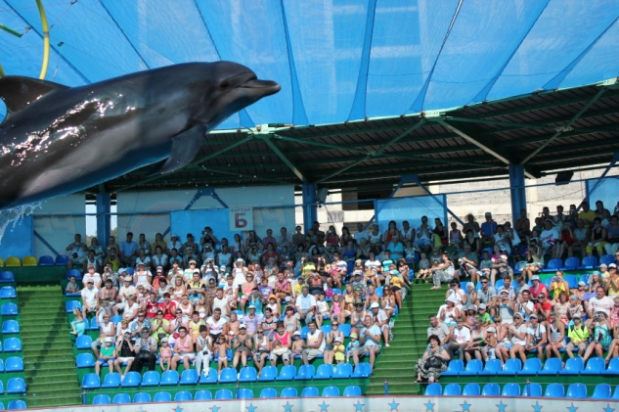
When we draw, skies were blue and clean.
When we came, they were spoiled at once.
Rain was ruthless that day I mean
And we hadn`t prospect or chance
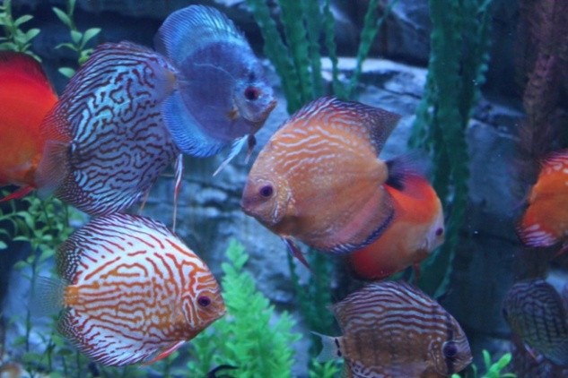
To stroll currently to the beach,
Venerate the waves` flow and stream.
Rainstorm raged, and we couldn`t reach
The sea cost from a common dream.

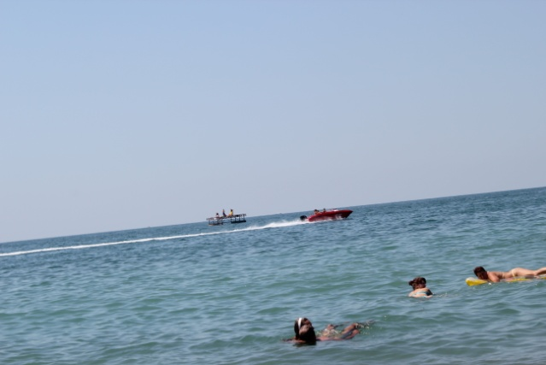
Skies were black almost for four days,
And we sat in the one hotel.
After that dull and boring phase
We relaxed there rather well.

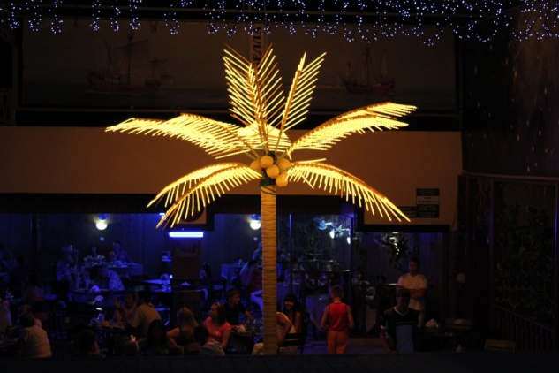
But now I have to end my rhyme
`Cause it`s night, and my clock shows three
It is not the adequate time
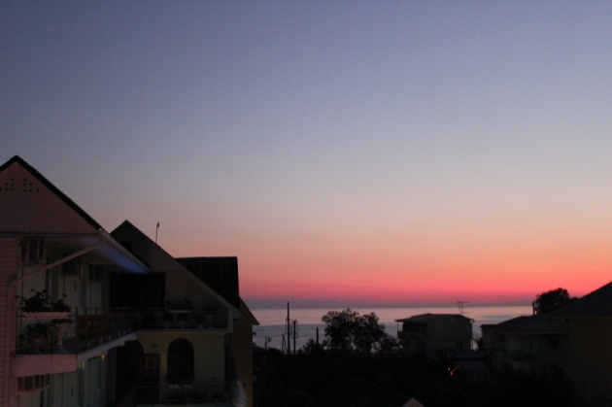
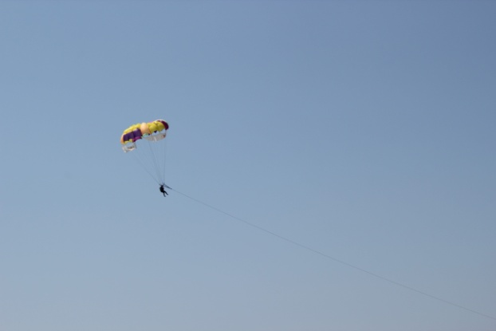
For a pupil. Don`t you agree?
Фотографии взяты из семейного архива семьи Монько и размещены с разрешения родителей.

