My summer adventure
Автор: ученица 10 б класса Ивлева Полина
Учитель: Костылева Елена Васильевна
Школа: МБОУ СОШ №6
Населённый пункт: город Красноуральск
Регион: Свердловская область

Summer is over but when I open my photoalbum and look at the photos taken in Egypt I remember it again and again. The trip to Egypt in June became an amazing summer adventure for me.
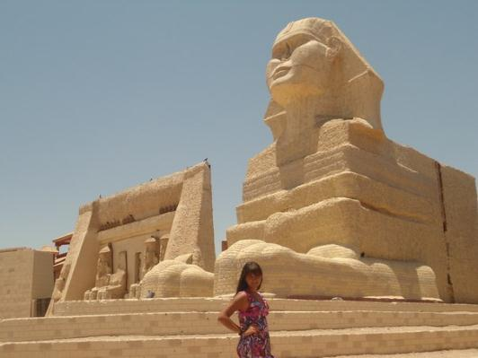
It began at the airport where my family arrived to catch a flight to Hurghada. We checked in our baggage, went through customs and passport control.The flight was on time and in four hours we arrived in Egypt.We lived in Alf Leila Wa Leila hotel. We liked to swim in its wonderful pool. We also sunbathed on the beach and swam in the Red Sea.We went on an excursion to Luxor, the most important and dramatic place inEgyptian history.

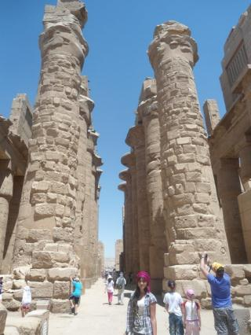
There I saw the tombs of Ramses, Tutankhamon, Queen Hatshepsut, Nefertiti and Nefertati. I visited the temple which was erected in ancient Egypt by people with their own hands. The temple impressed me greatly. I touched its walls which were thousands years old. I learned a lot of interesting facts about pharaohs, queens and their families. The excursion was very informative and though the temperature was fifty degrees above zero, I wasn’t tired at all.
The trip to Luxor also included a ride across the Nile River. The Nile for Egyptians is a source of water they drink. There are not any crocodiles in it now but there are Nile lizards.The guide told us about their sharp teeth and we didn’t dare to dip our hands into muddy water

of the Nile. I couldn’t believe I saw the longest river of the world.
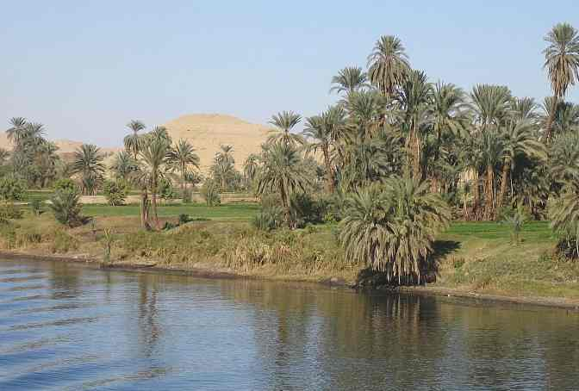
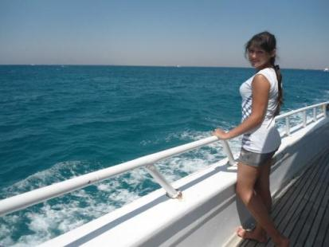
In a few days we went on an excursion to the Island of Paradise.We sailed on a large yacht there. The guide told us about the history of Egypt, joked and showed us how to make different things from the towels. Soon we were in the heart of the coral reefs. We saw corals and fishes of different colours. We got masks and flippers and dived into the water. I saw a lot of exotic fishes.The guide warned us not to touch corals. He showed us poisonous corals and fishes. For example, having touched «stone» fish one could die within 15 seconds. We were scared and swam up quickly. Then we sailed up to the Island of Paradise. We enjoyed its beauty, white sand and tall palm trees. The water was transparent and we could see seashells on the bottom. It was a fantastic excursion.

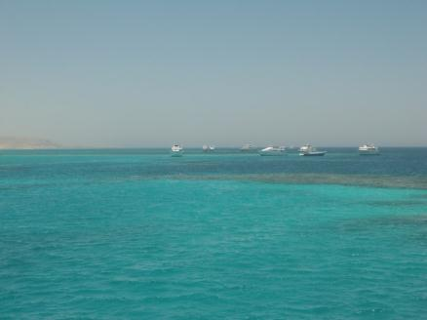
The trip to Egypt was unforgettable. Now I’m dreaming about a trip to Cairo, Egypt, where I’d like to visit the great pyramids of Cheops.

Ресурсы

Фотографии из личного архива семьи Ивлевых.
Фотографии несовершеннолетнего публикуются с согласия родителей.

