“ MY SUMMER ADVENTURE”

Автор: ученик 9 класса Мусин Антон.
Учитель: Пешкова Галина Владимировна.
Школа: ГБОУ ЦО№1419
Населенный пункт: г. Москва

Hello. My name is Anton and last summer I was in Spain.
The flight was difficult – we had one change in Switzerland, where I bought nice watch.
It was an exciting trip, we visited many cities and towns, saw different sights.
When we arrived inValencia, the yellow mini-bus delivered us to our apartments. It was so cool! Two floors, two bathrooms, a kitchen and even a swimming pool near our house!
Next day the weather was fine. It was a little bit hot but the Mediterranean Sea was quiet and warm. We were swimming all day long.
Spain is famous for its sights, nature and original culture. But I must say that food and shopping might be included into the list of entertainments in this country. There are a lot of not expensive shops, supermarkets, malls, fair or fashion boutiques- all of them have rather low prices. That’s why we bought some things to wear and other stuff. It was fun to dress up in funny clothes and make faces.

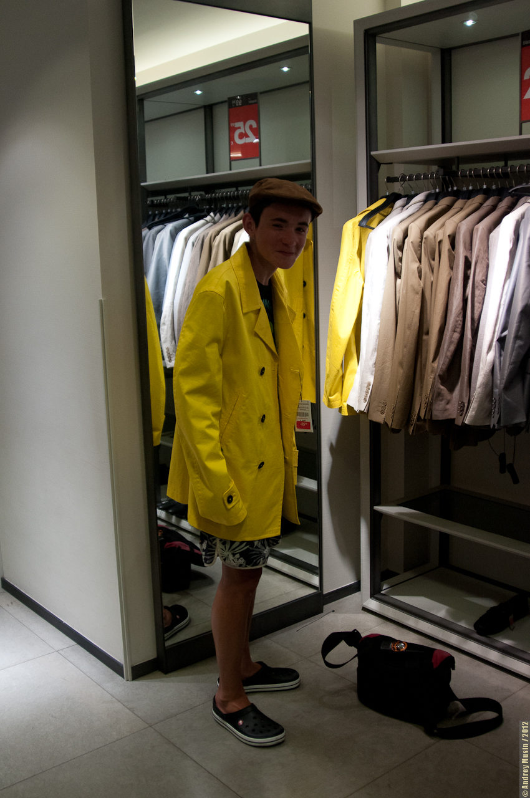

Food is another attraction. One can find any dish that meets your taste. My favourite is “Jamon” – salt smoked pork. It is very cheap and popular in Spain, but it costs too much in Moscow. It was my great pleasure to eat it every day.

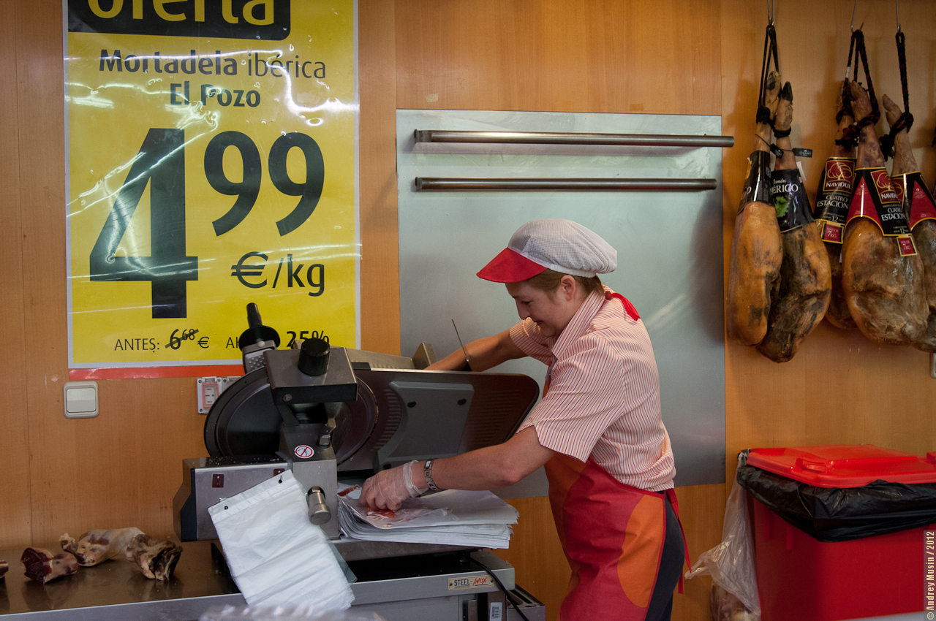

When my family and I were in Barcelona we visited beautiful Park Guell. There were a lot of trees, flowers and interesting buildings there. Antonio Gaudi wanted to construct a town-park where people could live using internal infrastructure-stores, bakery shops, schools etc. I loved that idea too and wonderful nature and houses impressed me very much.

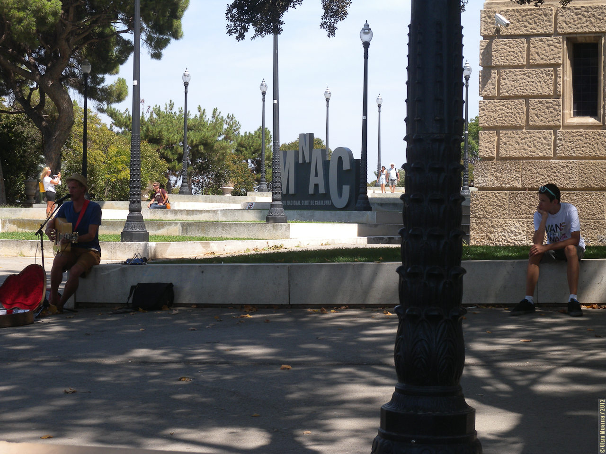

Another interesting sight is «Basilica de la Sagrada Familia», it was the largest project of Antonio Gaudi. This cathedral is not built yet, because charity money only is not enough
to finish it.

t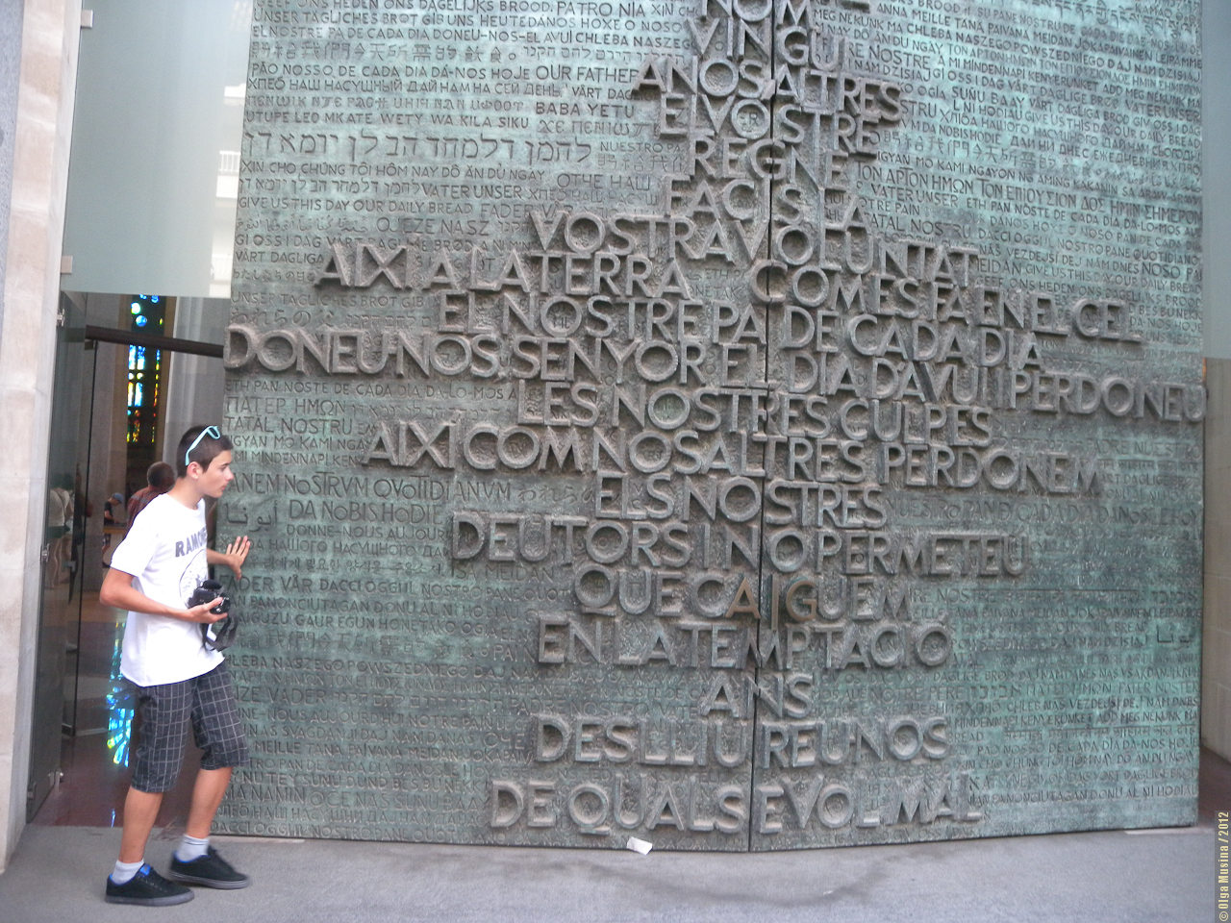
But the trip to Spain wasn’t so perfect as it could be. During our stay in Barcelona we had got a crime incident with our car. The thing was that. We’d left our car at a free parking space, and the thieves crushed the door window and stole our bags. It was rather strange but we found our bags round the car. Moreover nothing had been stolen. Everything was settled and we went on with our tour.

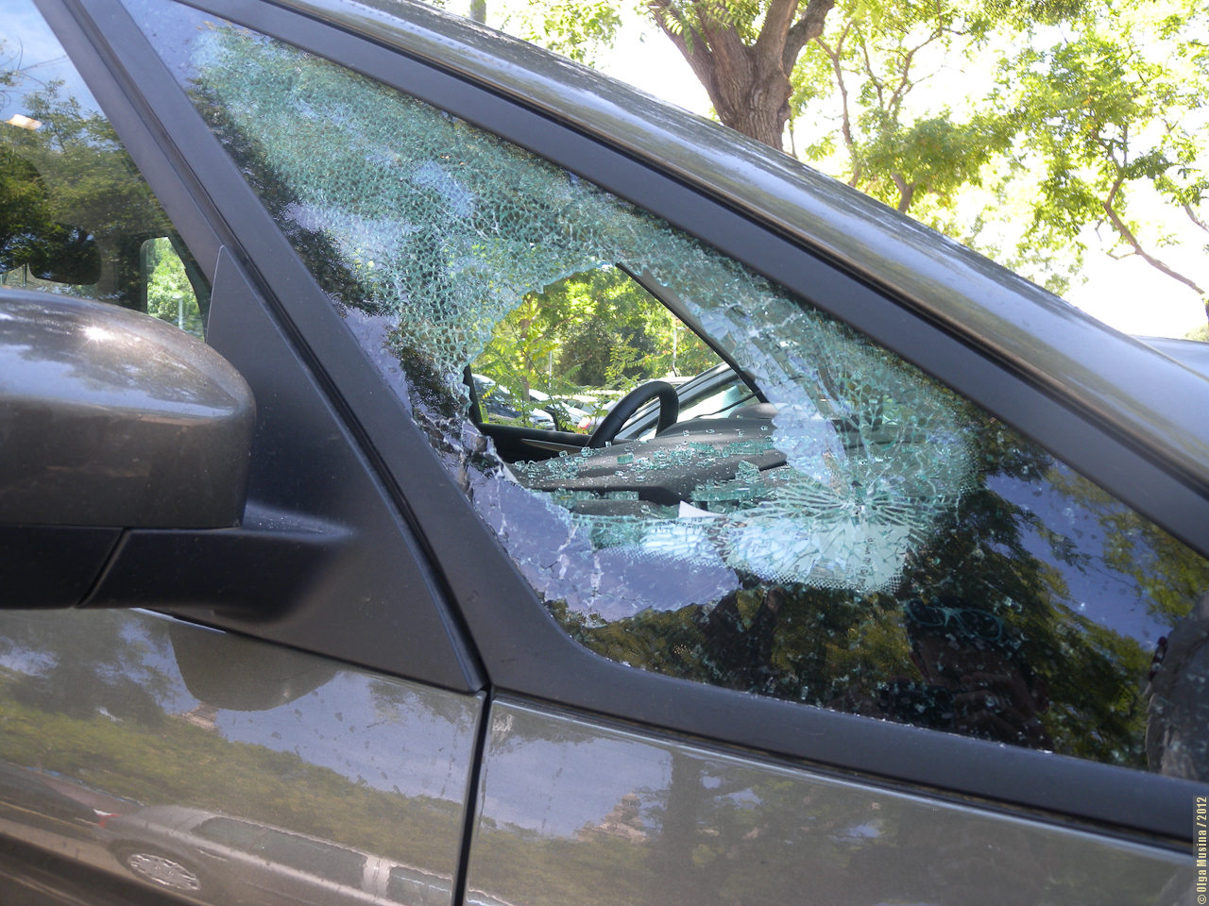

“Park Adventure” –a rollercoaster park is my dream and fun. I tried a lot of rollercoasters and it was great. It was unforgettable, and sometimes really scary, but it was great. After such an experience it wasn’t very attractive to go the water park nearby.

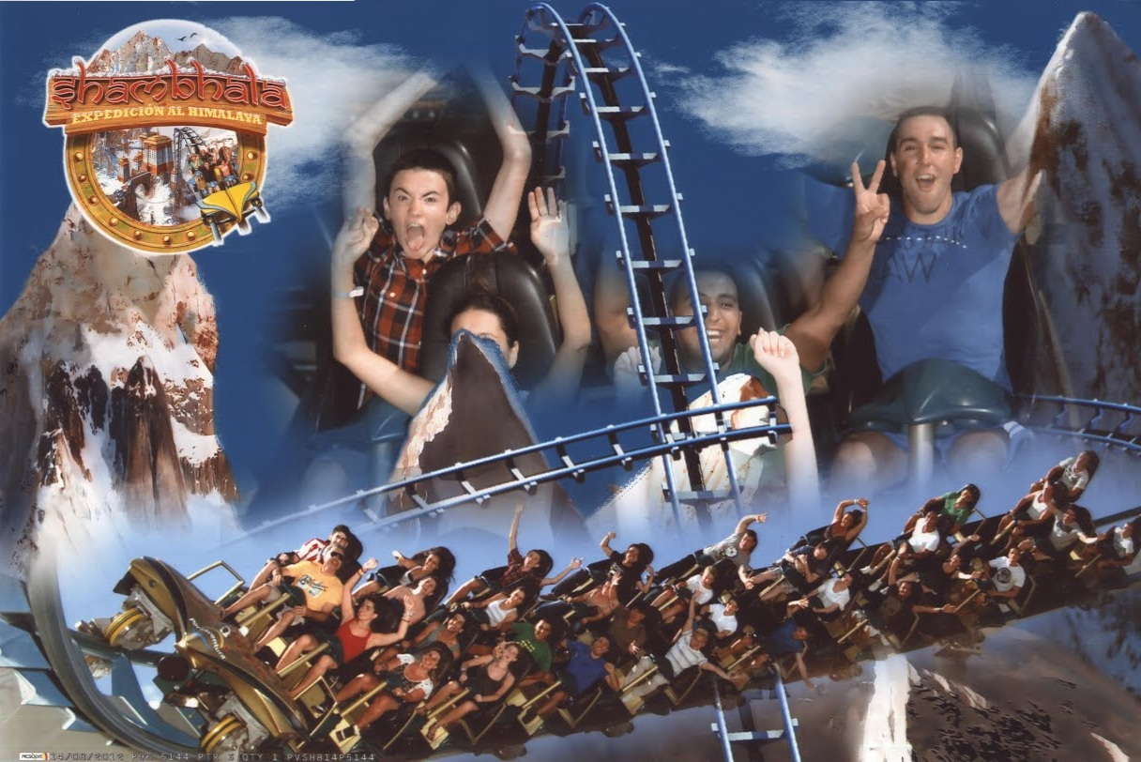
I enjoyed my trip to Spain and I dream of returning there someday.

Фотографии взяты из семейного архива семьи Мусиных и размещены с разрешения родителей

