“My Summer Adventure”
Автор: ученица 11 класса Хрипунова Христина
Учитель: Ефремова Алла Юрьевна
Школа: МБОУ «СОШ №4»
Населенный пункт: город Муром
Регион: Владимирская область

“My summer adventure”
This summer I visited two beautiful cities in our country. They were Moscow and St. Petersburg.
At first I was in Moscow. Moscow is the capital of Russia. The competition “The World Children’s Winner Games” took place there. I took part in it too.” The World Children’s Winner Games” are the games for children who have recovered after heavy diseases. They were competing with each other as at real Olympic games. Different types of sport such as football, chess, swimming, ping pong, shooting were held there. The children came from different countries. They were from Poland, Belorussia, the Ukraine, Germany, Hungary, Pakistan, Azerbaijan, Serbia, Romania, Armenia, Russia and Lithuania. On these days I was invited to this competition as a photographer to take interesting pictures. I started to make photos when I was treated in hospital in Moscow where I met Yuri Khramov. He is a photographer and the principal of the charitable project “We Live on This Earth”. It started being my hobby. During the games I met many young people who also had had an oncological disease as me. They were photographers too. Also I met some volunteers. They are people who help children who are ill. They encourage them at hard time. The children played, communicated and made new friends on this games. I made some new friends too. I took many photos. You can see some of them on an official site of the fund “Present Life”. We also learned a lot of new things about photographing. It was unforgettable. I’m looking forward for the next games with impatience.
Then my mother and I visited St. Petersburg. We had been living in the hotel for six days. It is situated near Palace Square. We were walking along Nevsky Prospect. This is Petersburg’s main street and it runs almost five kilometers. Also I and my mum visited many museums such as the Hermitage (it has the richest collection of pictures in the world), the Pushkin’s museum (this museum presents the apartment where Pushkin lived his last years and died there), the Marble Palace (there took place an exhibition of modern painters) and the Russian museum (this museum has a lot of original pictures by famous Russian painters). Then we visited many different cathedrals and monasteries. They were the Alexander Nevsky monastery, the Issakevskiya cathedral, the Kazan cathedral, the Troitsk cathedral and many others. St. Petersburg has a large amount of bridges, most of them are drawbridges. One night we went to look at the opening of bridges. As well we went to Peterhof. There we admired its fountains. They are very beautiful, unique and great. We were walking through the park and we could see the Gulf of Finland. In Petersburg we also walked in different parks a lot. My mother and I really liked our trip to St. Petersburg and I wish everyone spent there them summer.
This summer I felt joy, my adventures made great impressions on me. I’ll never forget them.
The young people from the project “We Live on This Earth”
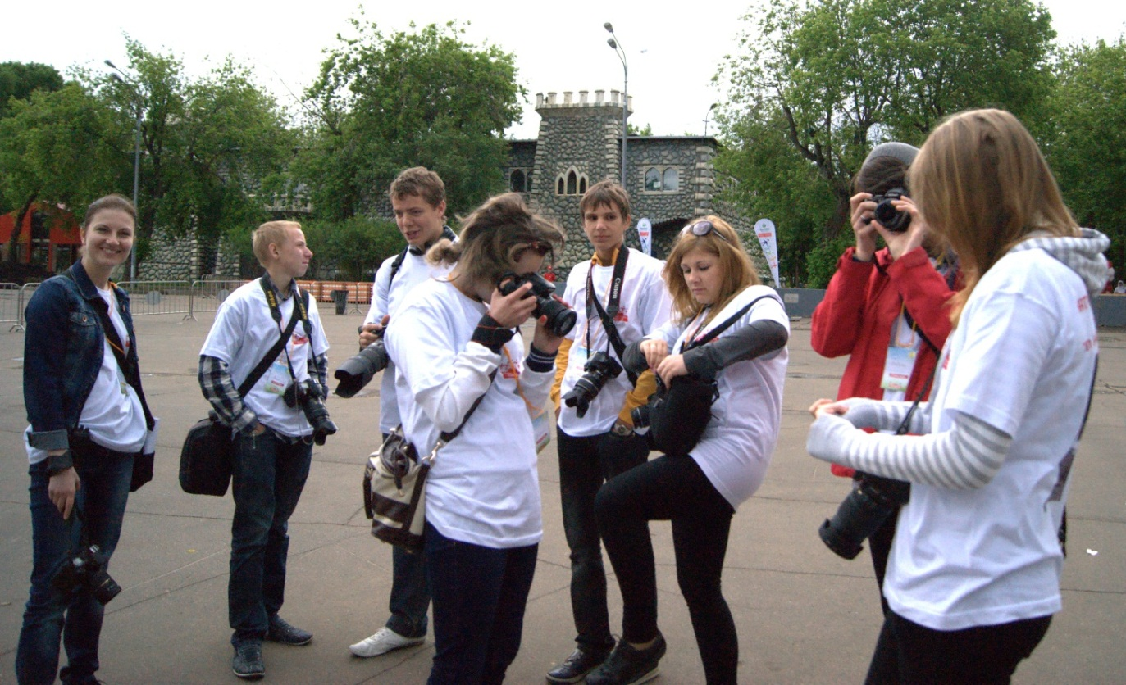
The teams from Belorussia, Azerbaijan and Germany
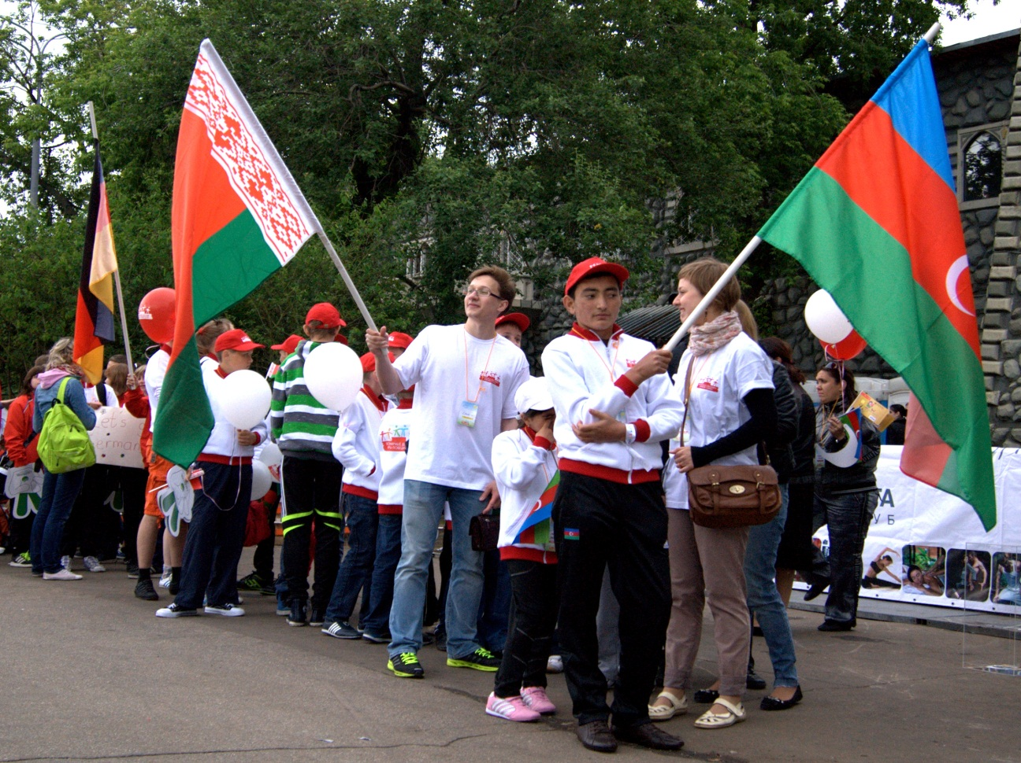

The teams from Pakistan, the Ukraine, Romania and Russia
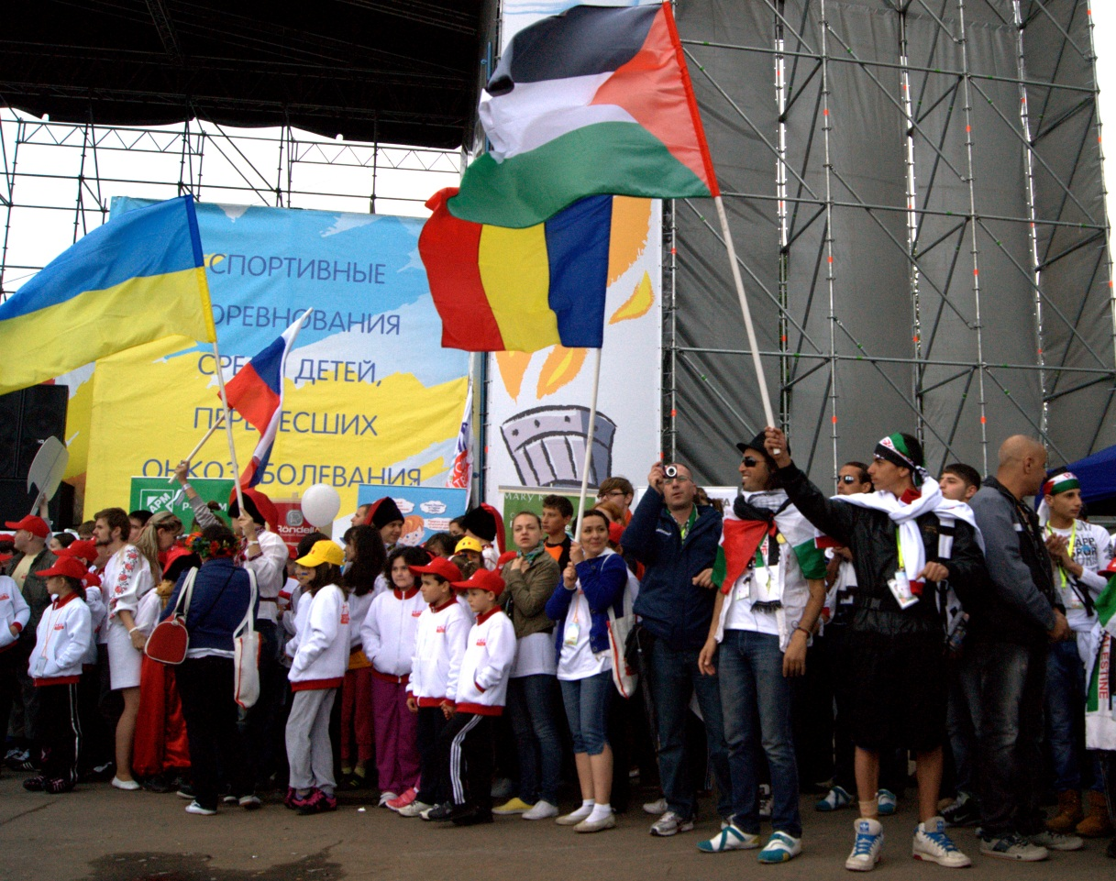
Chess
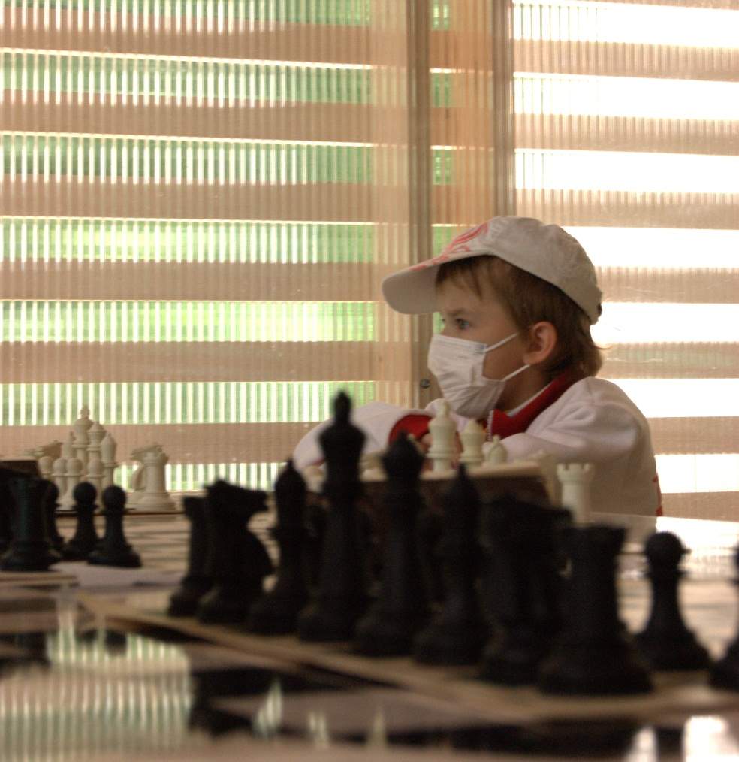
Football
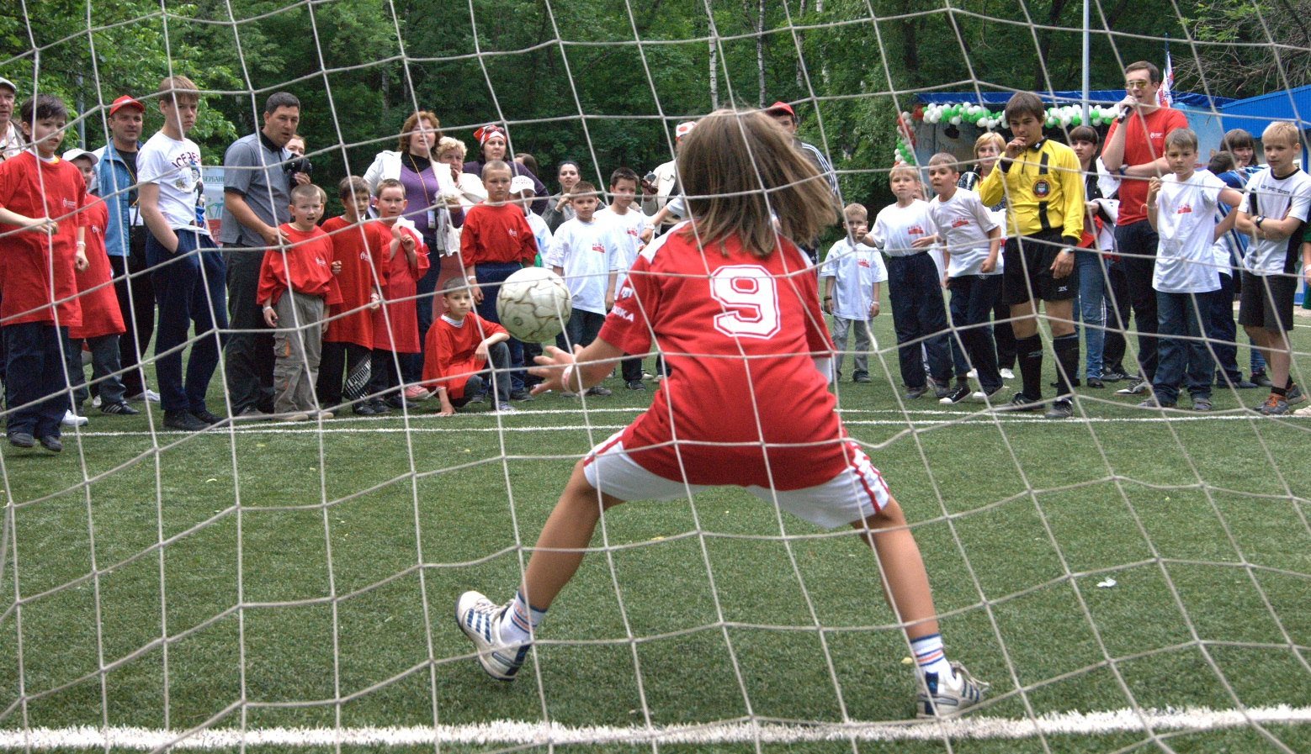

St. Petersburg. Peterhof
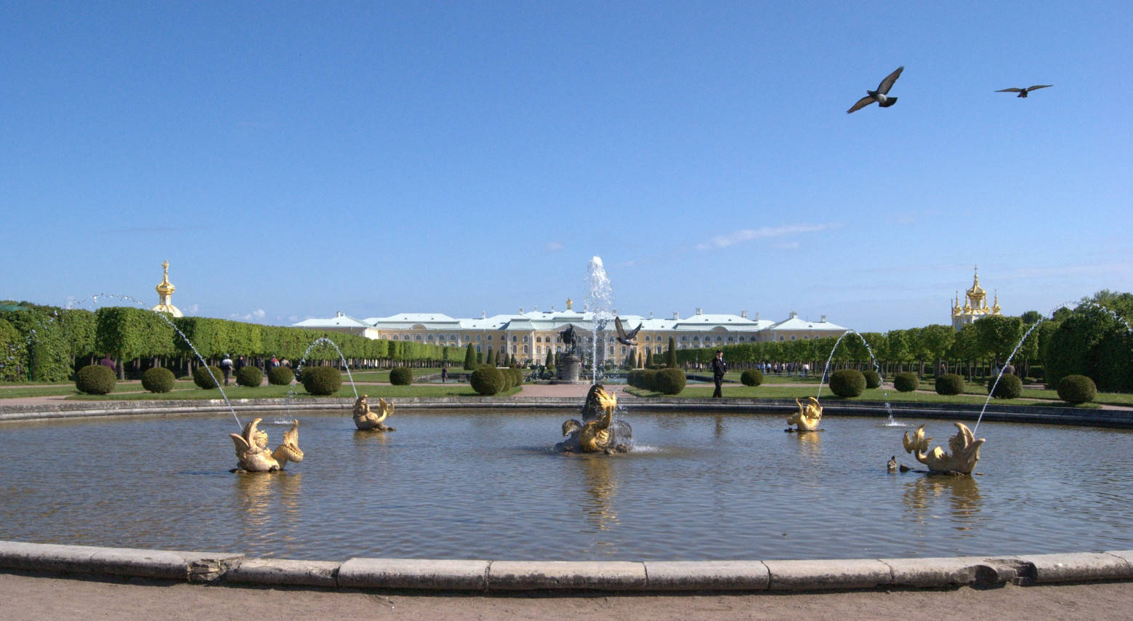

The fountains of Peterhof
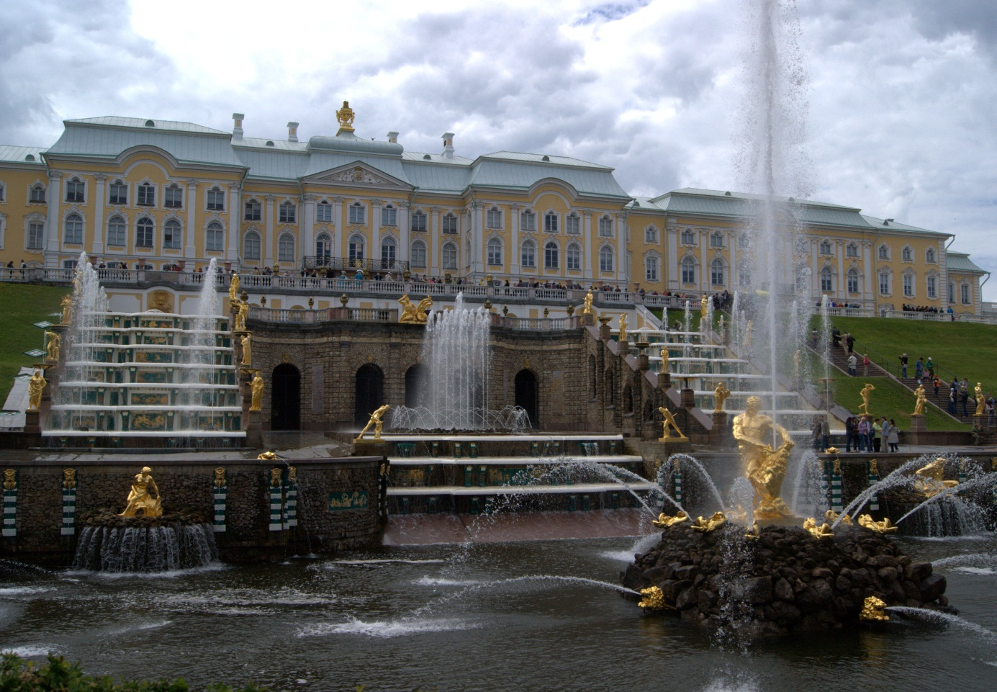
The Palace drawbridge
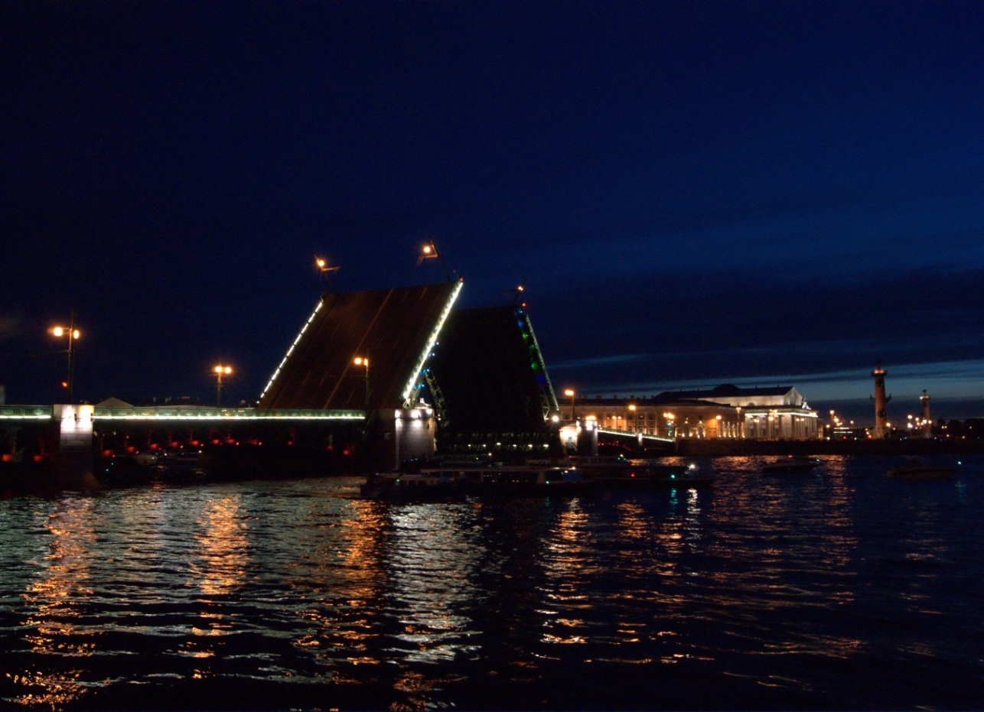
Фотографии взяты из личного архива автора и публикуются с согласия родителей.

