My summer adventure
Автор: ученица 7 «а» класса Постникова Дарья
Учитель: Костылева Елена Васильевна
Школа: МБОУ СОШ №6
Населённый пункт: г.Красноуральск
Регион: Свердловская область
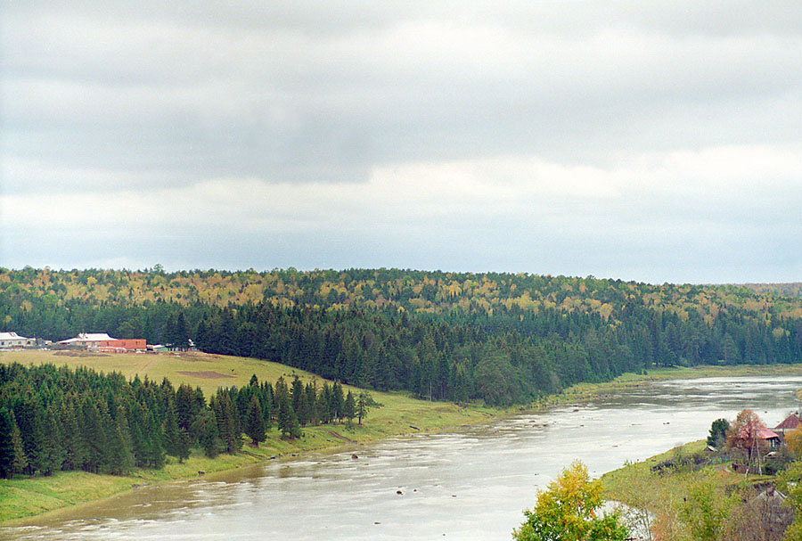

This summer was wonderful! First of all, my younger sister Sofia was born. It was very exciting for me. Now I am an elder sister and have a lot of duties. I am so proud of it. I help my mum to take care of Sofia. She is so cute.
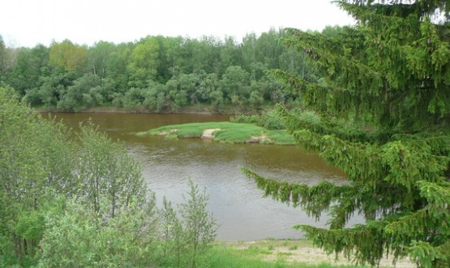
And there was another event that made the summer unforgettable. On June 31 I went camping. That was a real adventure for me.
I went camping with my girlfriend Natasha and her dad. We drove to Verkhoturye. Natasha's dad found a nice campsite near the Tura river. We put up a tent and went swimming. The water was very warm. We swam and played in the water, after that we rode on a catamaran. We had fun! It was a real surprise for me and I enjoyed it a lot.
In the evening we made a fire, sat near it, ate and talked. It was late when we went to sleep in a tent. We told funny and scary stories and were so excited that couldn’t fall asleep for a long time. It was my first sleepover in the forest.
In the morning we woke up very early and ran to the river. We watched the sunrise. It was so beautiful! The water was warm again and birds sang their charming songs.
Natasha's dad made kebabs for breakfast, we ate them and went fishing. We were lucky to catch three perches. After that we went for a walk in the forest. I enjoyed beautiful summer nature. We made nice chaplets out of dendelions and ox-eye daizies. We saw squirrels, they were small and jumped very quickly from one tree to another.We watched them for some time and went farther. It was great to walk in the forest which was full of surprises. Suddenly it started raining and we ran to our tent. We got wet but were happy.
Our trip lasted only two days but I still remember it and make plans of going camping next summer again.
It’s worth going camping!

Ресурсы:
http://laya.e-tagil.ru/e107_files/public/1242281123_1_FT15_reka_tura.jpg

