“My Summer Adventure”

Автор: ученица 5В класса Коноваленко Ксения

Учитель: Бакунина Юлия Валерьевна

Школа: ГБОУ ЦО №1419

Населенный пункт: Москва

Регион: Москва

My summer adventure
This year I spent summer vacation in many places – I went to the sea, I lived in our country house, then in my sister’s country house. All my dreams came true this summer.
At the very beginning of the summer holidays my friend Taja came to our country house and we had a lot of fun together. I and Taja rode bicycles, ran a lot and played football with boys.
Then I went to Thailand for a week. We flew nine hours on a plane and arrived in Phuket. I saw many tourist places. First we went to the Crabi Island in a speed boat and swam in the lagoon with small fish. Forests in Thailand grow in water. We also went in bamboo boats along a small river. There were many big butterflies and frogs there. I also saw the King’s project on turtle farms. We visited the farm where they grow different fruit and an elephant fantasy show. We were in the park and we saw many fish. When we gave them food a thousand of them rushed to take it. There were also many turtles, old and young. I took a ride on an elephant. I liked Thailand very much. The weather was good and I swam a lot. I made many new friends and had a lot of fun.
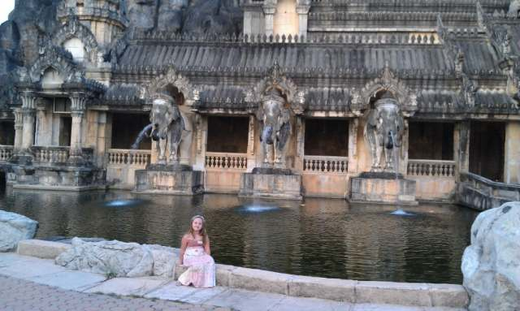
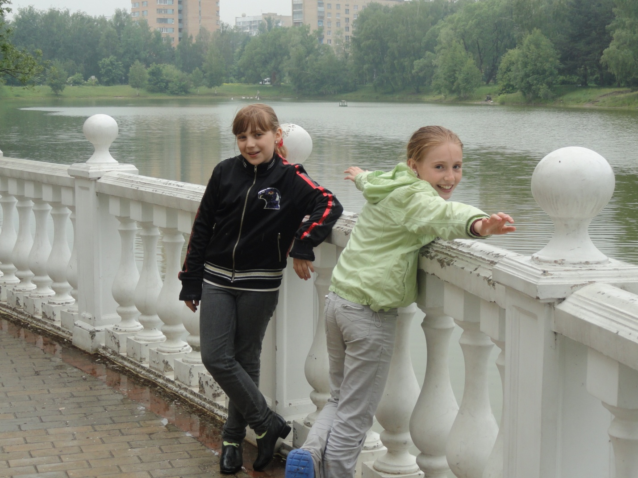
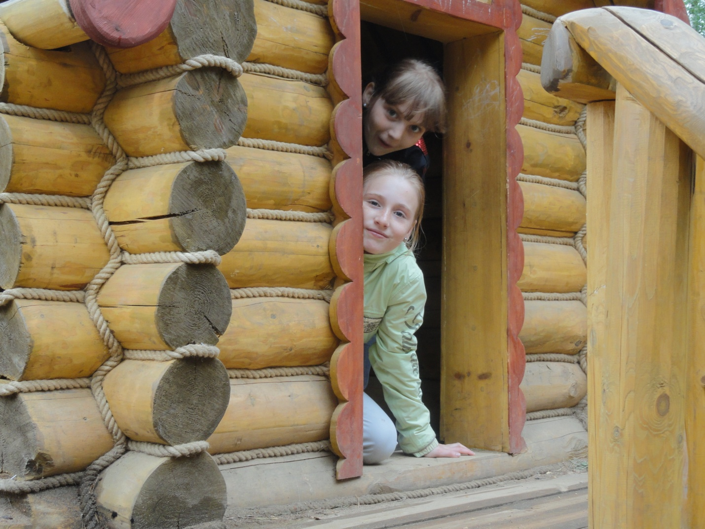
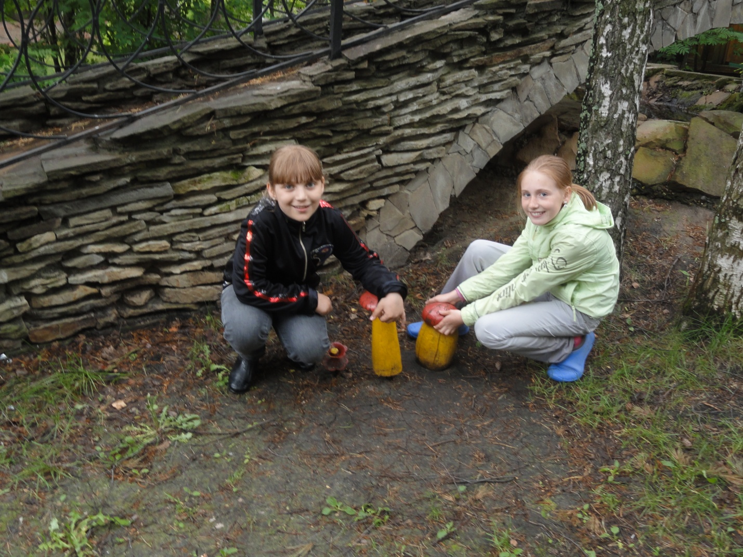
When I came back to Moscow I went to our country house. In the country I rode a bicycle a lot and read interesting books, played the piano, sang, drew pictures and helped my granny in the vegetable garden. My granny and I grew flowers, took out weeds and grew many vegetables. In the evening my friends and I made fires. We also made feasts, concerts and many other interesting things. I liked birthday parties of my friends. We had a lot of fun. The most interesting things were “try to catch me” bicycle racing, hide and seek and tuki-tuki. In the children’s playground we had “extreme” swings. They are extreme because they fly very high. We went to the “Solnyhzko” café. We told horror stories and anecdotes. We even studied together, watched movies and cartoons. My favorite film is “Elvin and Ground-squirrels”. Ground-squirrels brothers are Elvin, Simon Theodore and their ground-squirrel sisters Britany, Jannett and Eleanor. We also watched a film and then discussed it, played play stations, watched TV and played with mobile phones. It is bad for the eyes and we did it very seldom. We were outdoors a lot. When it rained we sat at home or visited friends. We also went to the forest with parents to gather mushrooms and berries. We made herbaries. We also had picnics, we sang and danced there, played with a ball, made fires, told stories. Our country house is near Zvezdnij gorodok. Cozmonauts live there. We often go there and saw Alexei Arkhipovihc Leonov, a Russian cosmonaut. Near my country house we have an old car. It is thirty five year old. My grandfather left it to us. It is our biggest toy. All children of our street love it. I have many pets in the country. My favorite dogs are Boss and Dora. They are very funny, gay and kind. The best pet is my cat Busja. It catches mice and lizards. My friends and I like to play football. We play our own games – “eleven”, “family”, “penalty”. We also like to play basketball, we play our favorite games – “double touch”, “one touch”, “eatable” – ”uneatable”, “pioneer ball”. This summer we had guests from Khabarovsk. We showed them all interesting places in Moscow - The Red square, Poklonnaja gora, the Zoo. Our guests liked Moscow very much.

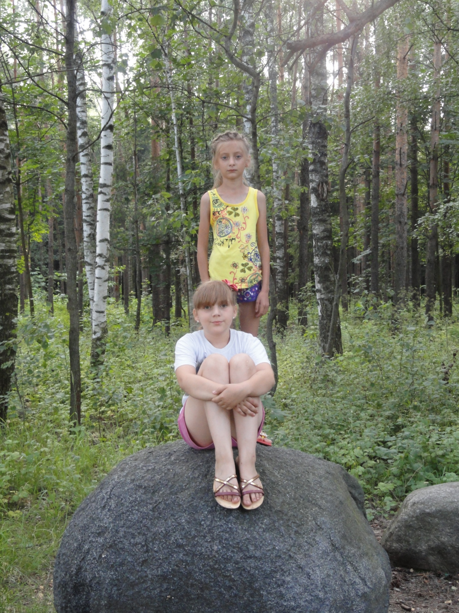

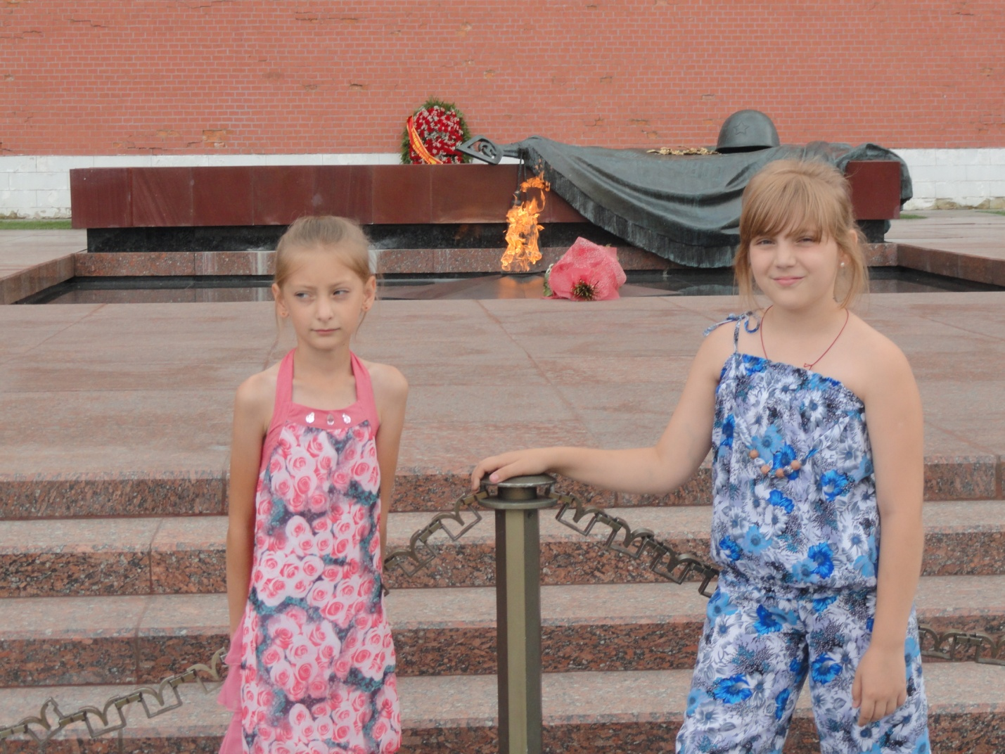
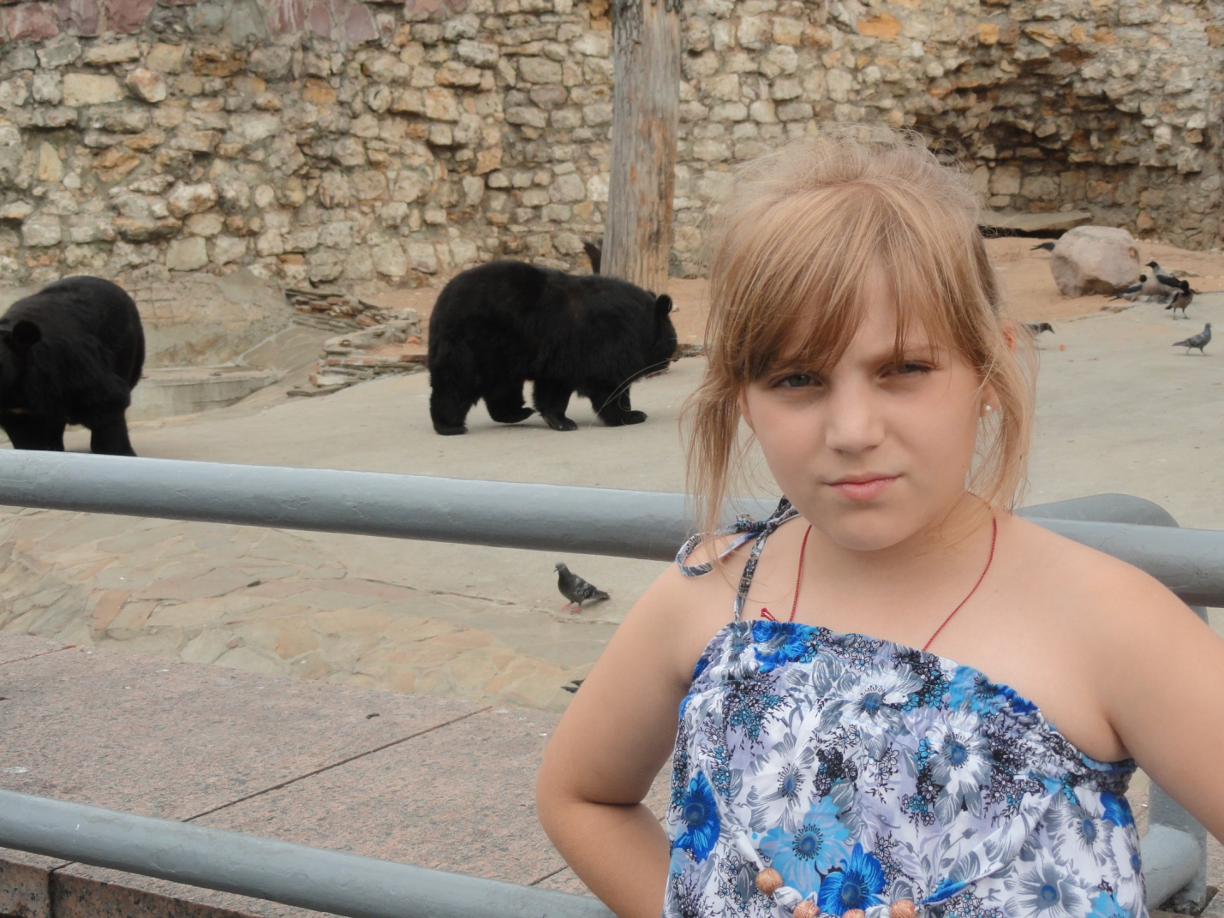

Then I went to visit my sister’s country house. There I got a present. It was Ipad 2. It was my dream. My sister’s name is Mariam. Each day we swam in the pool and played. Together we went to the Vegas center and saw a cartoon. It was “Ice age 4. Continental drift”. Then we went to a café and ate a lot of ice cream. We had much fun, made concerts, sang, danced and made other funny things. We ate pizzas and cake “Napoleon”. We watched many films and cartoons, played Ipad. We also played with the kittens, drew pictures, sunbathed, went to the bath house, rode bicycles, drew with chalks. We had great fun together with my sister. I had a great vacation but the summer is over. It was very interesting. Now I must study. I think time went too fast in summer. It is not clear where summer was hurrying. It should be as slow as a turtle. Anyway it was great.

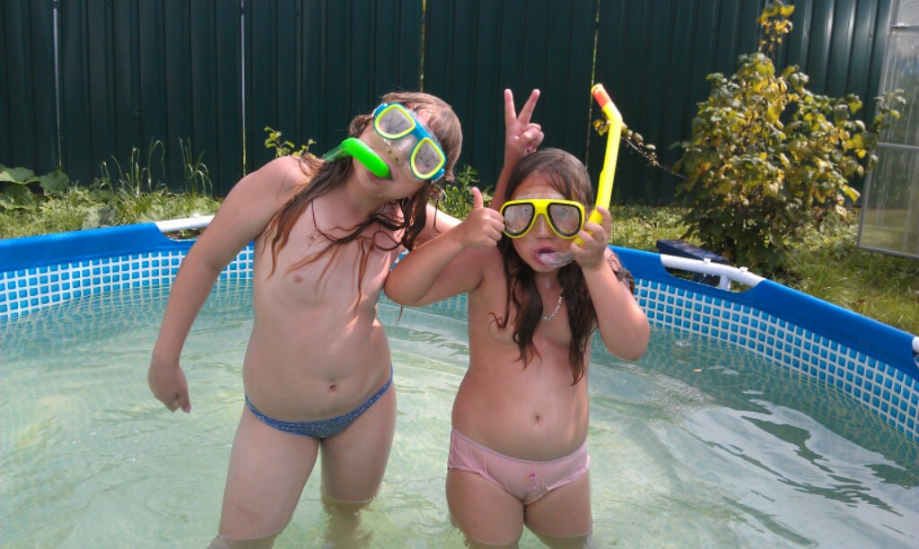

Фотографии из личного архива семьи Коноваленко, публикация фотографий несовершеннолетней Ксении и ее подруг разрешена родителями.

