“My Summer Adventure”

Автор: ученица 8 класса Болдова Василиса
Учитель: Тиханова Ирна Петровна
Школа: ГБОУ ООШ с. Васильевка
Населенный пункт: село Васильевка, муниципального района Безенчукский
Регион: Самарская область.

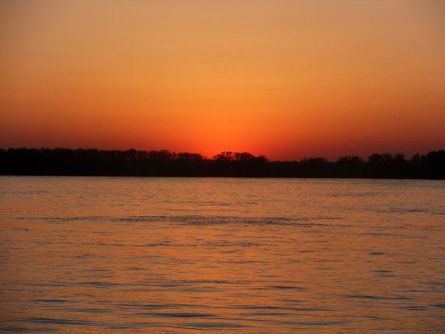
As for me summer is the best season. The school year ends and I can have a rest. This summer vacation was really wonderful. In June I went to Samara to my friend’s place. Samara is a very beautiful city. There are many interesting places to see and even in summer there are many interesting events to visit. I have been to many different exhibitions, f.e. “The cat exhibition”. There were a lot of cats and kittens. They were very nice. I like movies and in the evenings my friends and I went to the cinema and enjoyed the last films. We also walked together along the embankment. In my opinion we have one of the most beautiful embankments in the world. There are some fountains, paths for bicycle and rollers, small but nice and very cosy cafes. We spent good time there drinking tea with tasty cakes or eating ice-creams.
In July I have family holidays. My family and I went to the Vasilevsky Island. It’s a beautiful place on the Volga. We had our own house and we could do whatever we want. Each morning we started with a pool. What could be better in a hot summer day? We swam in the river and in the pool, walked through the pine forest.
And then came the last summer month and we went to visit my grand-great mother in Kanuevka. She lives in a small village in a detached house with a wonderful garden where are grown many different flowers apple trees with fragrant apples and. I haven’t seen my Granny for 10 years. We had a very good reunion dinner. We spoke about everything, watched old photos and remembered different stories. This summer holidays were very interesting and beautiful. I really enjoy this time.
Фотография из личного архива

