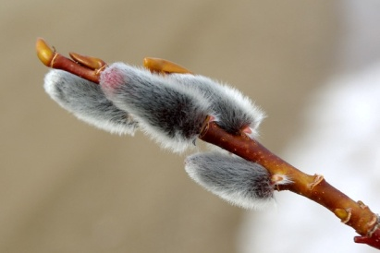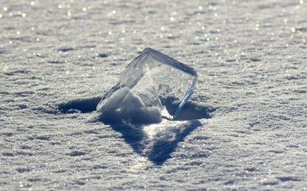

Автор: Колесниченко Влада,
ученица 8 класса
Учитель: Кошкина Галина Федоровна
Школа: МБОУ СОШ сельского поселения "Поселок Токи"
Ванинского района
Регион: Хабаровский край

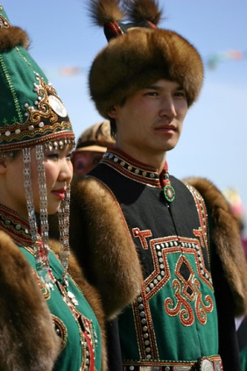
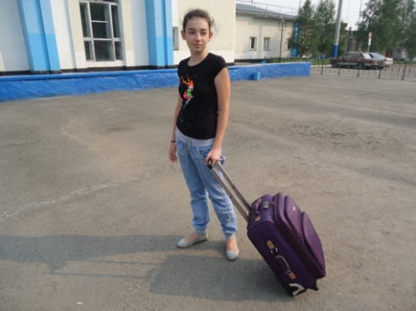
Hi! My name is Vlada. I am 13. I live in the Far East near the commercial seaport Vanino. My home village's name is Toki. It's on the shore of Tatar Strait. The climate is here cold. the summer is cool and foggy. The average summer temperature is 15 grade above zero . That's why many people go to travel in summer.
I think travelling brings a lot of impressions.
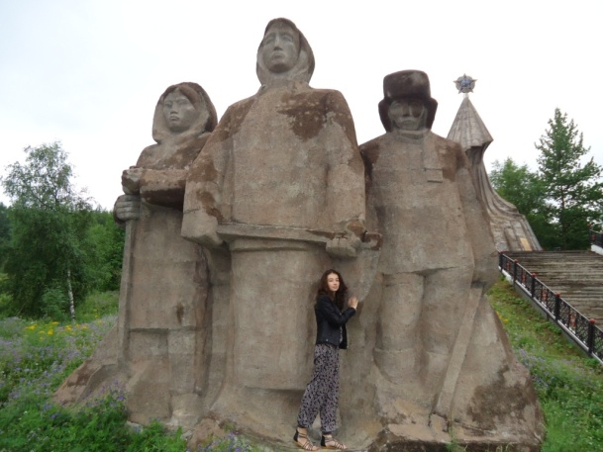
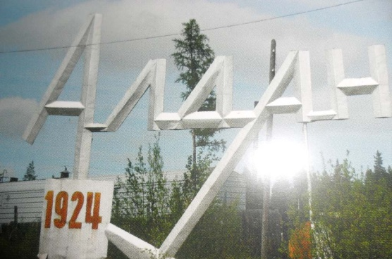
Last summer holydays I spent with my grandparents. They live in the South Yakutia in the small town Aldan. Aldan is known as the gold town because it is the leader of the gold extraction. These places are rich of gold. The town is 88 years old. It's yung but has it's traditions and places of visiting. For example, the memorial of the victory in the Great Patriotic war 1941-1945.
Aldan has it's unfogettable flavor. The old-aged taiga noises near the big buildings. Big stone buildings together with the small wooden houses. Many of them were built in 20 - 30 -ies.
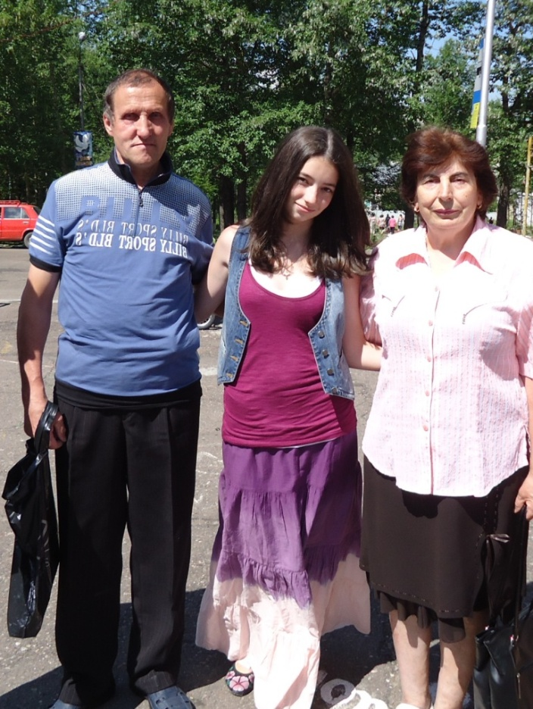
This small and modest provincial town can I name the hardworking town. Here are extracted tens of tons of gold to the state of Treasury.
My grandfather has been worked more than 30 years in the gold mining artel "SELIGDAR". He invited me to visit his working place. It was very interesting to know how the gold is extracted. I found that first workers dig a huge pit, find in earth layers gold and treat with alkali. The Golden sand is melt forming bars. This bar I was even able to hold in the hands. This excursion was a real summer adventure.
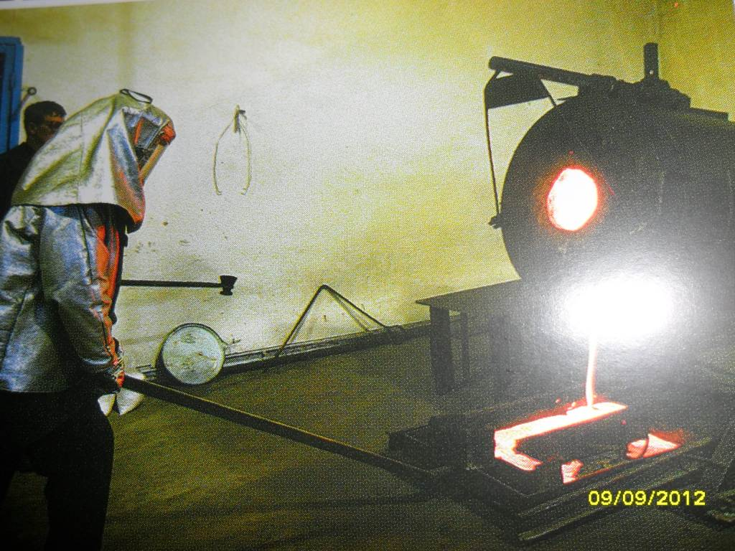
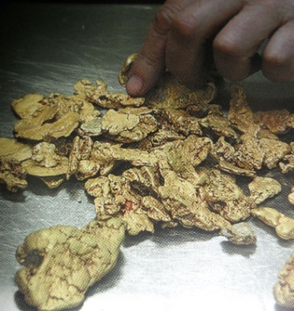
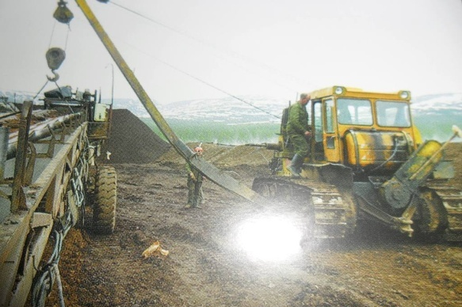

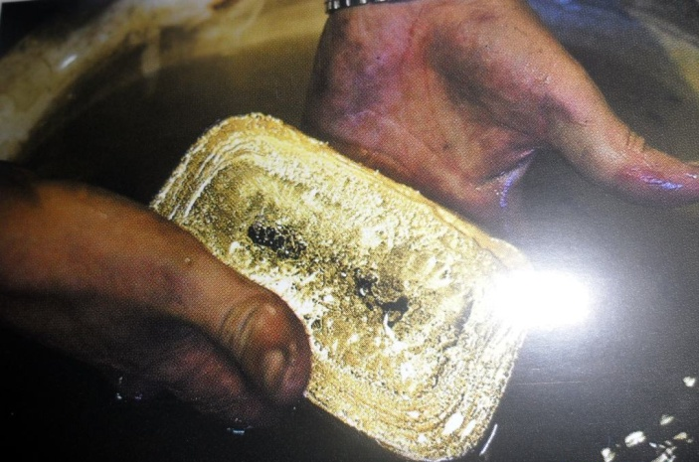

I think, you can better know your country if you will travel around Russia. Welcome to the South Yakutia!

Представленные в работе фотографии взяты из личного архива автора работы и разрешены родителями публиковать их.

