Автор: ученица 9Акласса Шевелева Наталья Вадимовна
Учитель: Шевелева Юлия Александровна
Школа: МАОУ «Мысовская СОШ №56»
Населенный пункт: г.Бабушкин
Регион: Республика Бурятия

My Summer Adventure
Summer is a wonderful time for relaxation. It is a favorite season for students, because they can have holidays. Some of students usually play with friends all day long; some of them have nothing to do, lie at the seaside getting a lovely tan. But for me summer is the best time for adventures and discoveries. In spite of the fact that I’m only 14 I had an opportunity to see the life of don Cossacks in Rostov on Don, to walk in the Old Park in Gelendzhik, to breathe the sea air at the seaside of the Black sea in Sochi, to observe the life of camels and a small tornadoes in Kazakhstan, to enjoy the beauty of mountains in Alma-Ata. But the most interesting summer adventure has happened to me this summer.
Our friends from Germany (we have been friends for 16 years) invited me to travel around Lake Baikal together. This suggestion was unexpected for me because my family has been living on the shore of Lake Baikal in a small town Babushkin and it seemed to me that I knew about Baikal everything. A wish to meet my old friends was strong and I looked forward to travelling with them.
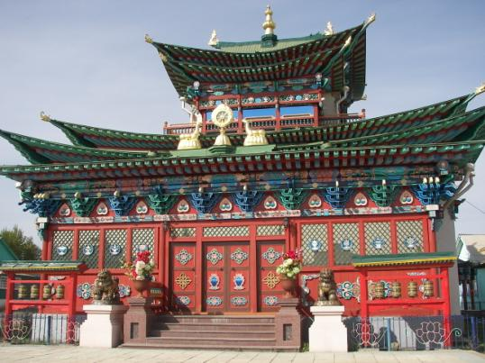
Our meeting was in Ulan-Ude. I was very surprised when I saw not only my friends, but their neighbours, too. Friends’ neighbours spoke only German, but I didn’t know German and my English needed improving, I began to speak English with them. It was my first experience to communicate with foreigners.
In Ulan-Ude I had an opportunity to visit Ethnography museum of Zabaikalia people where I got to know very interesting facts about the life of buryats, semeyskie, evenks, about their houses.
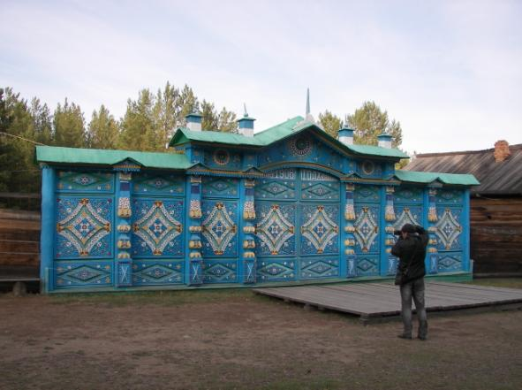
This museum is on the open air, that’s why we could walk and watch wild animals on its territory. It’s important to say, that our friends went to Russia every year and they had written a guide-book about Baikal for German people. They know about Baikal much more than native inhabitants and it was very useful for me.

A long way from Ulan-Ude to Ust Barguzin by bus was very funny and interesting. We had a good time together. It took us 5 hours to get to Ust Barguzin, where we lived for seven days. I thought that it would be very boring: to stay at one and the same place for seven days, but I was mistaken.
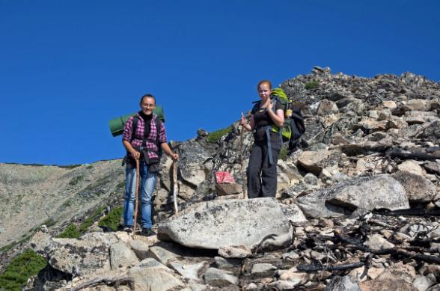
The first day on the shore of Baikal wasn’t hospitable: it was windy, because of the huge waves we couldn’t swim. At night we sat around a big camp fire and sang guitar songs.
The next day six of us and of course me, went to the peak Svyatoy Nos (The Holy Nose).
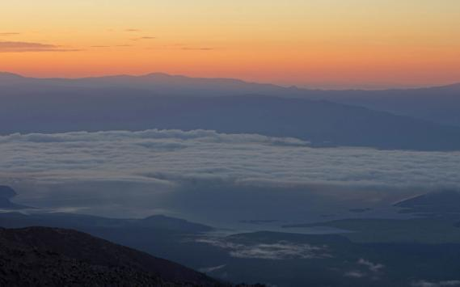
Its height is 1900 m. All day long we climbed with heavy backpacks. We were glad when reaching the peak. It was very cold; we made a camp and enjoyed the beauty of mountains and the view of Lake Baikal.
Far stars seemed to be very close. All the next day we descended. It was more difficult than to climb. The food and water was over, our feet hurt. It was an extreme adventure.
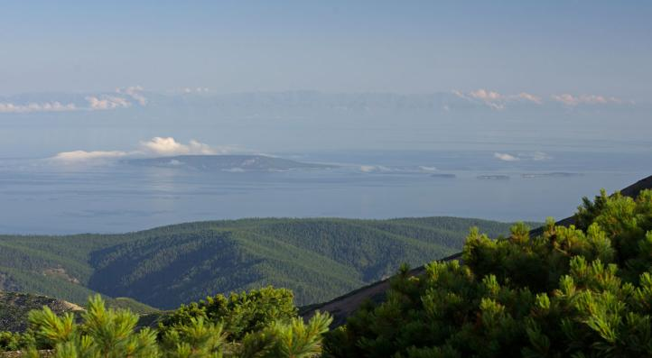
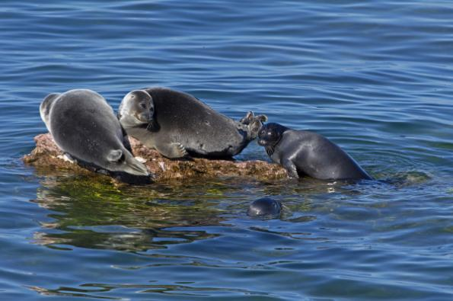
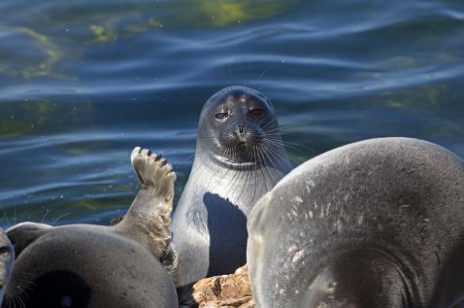
The fourth day of our travel was the most unforgettable. In the morning we went to Zmeevaya Bay by ship. This place attracts people by its hot springs. Then we were invited to travel to legendary Ushkanji Islands. On the way our motor boat was broken and we were staying in the middle of the lake while repairing. Soon we arrived to Ushkanji Islands.
I should say that it is the only place in the world where you can see Baikal seals in their native home. A lot of tourists dream of visiting this place. We had been watching them for a long time and made a lot of pictures. I had watched them only in a pool for seals in Irkutsk (Nerpinarium) before.
The other days were devoted to different excursions: we went to Barguzin, saw old Mongols stands and got to know a lot of interesting facts about Baikal and their inhabitants. The half of our journey was ended.
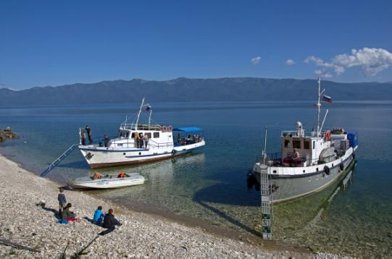
The next morning we went to Olkhon Island by ship «Rocket». Olkhon is the largest island in Baikal. Khuzhir is the most developed town on this Island. The beauty of Olkhon astonished me by high rocks, blue water, and sandy beach. It was as if I were on the Black Sea.

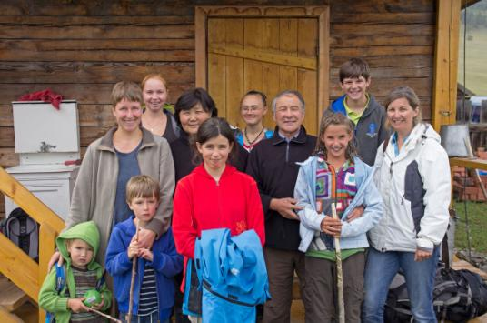
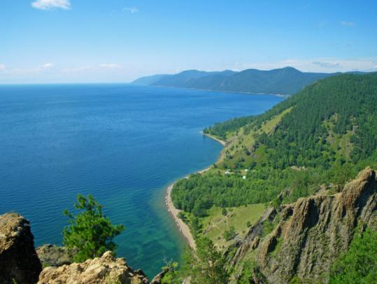
Two days later we went to Listvyanka. The hardest part of travelling began from here. For three days we had been walking through the taiga, climbing mountains. Sometimes we went along the shore of Baikal; sometimes we met obstacles, such as cliffs, streams, deep ravines. I was very surprised that there weren’t any roads: neither railway nor auto roads. We had to sleep in tents two nights. The weather was miserable, rainy, foggy and cold. Wet and tired we reached the aim and finished our journey in Bolshoye Goloustnoye (we went more than 20 km a day). In spite of the fact that journey was dangerous, I was very happy. The people who rented a house for our group told me that Bolshoye Goloustnoye is situated opposite my native town Babushkin and sometimes they could see the lights on the opposite shore of Baikal. I remembered my home, my family; my two little dogs and I missed them and wanted to go home.
The way home was through Irkutsk. The rest of my summer holidays we spent with our German friends in my native town.
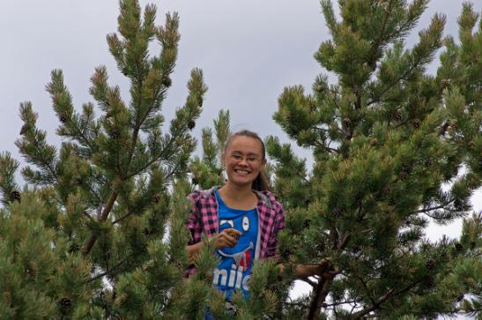
My summer adventures were unforgettable. I understood that I had known about Baikal nothing. And I came to the conclusion that the best way to study Geography is travelling.

Использованы фотографии из семейного архива и с личного разрешения друзей семьи Roger Just and Heike Mall.

