“My Summer Adventure”

Автор: ученица 9 А класса Анна Орлова
Учитель: Матвеева Ольга Васильевна
Школа: МБОУ «СОШ № 8»
Населенный пункт: г. Муром
Регион: Владимирская область

This July my mom and I spent our holidays travelling. My uncle was with us too, and it was much funnier with him. We were in one of the most beautiful cities in the world and in Russia – Saint Petersburg.
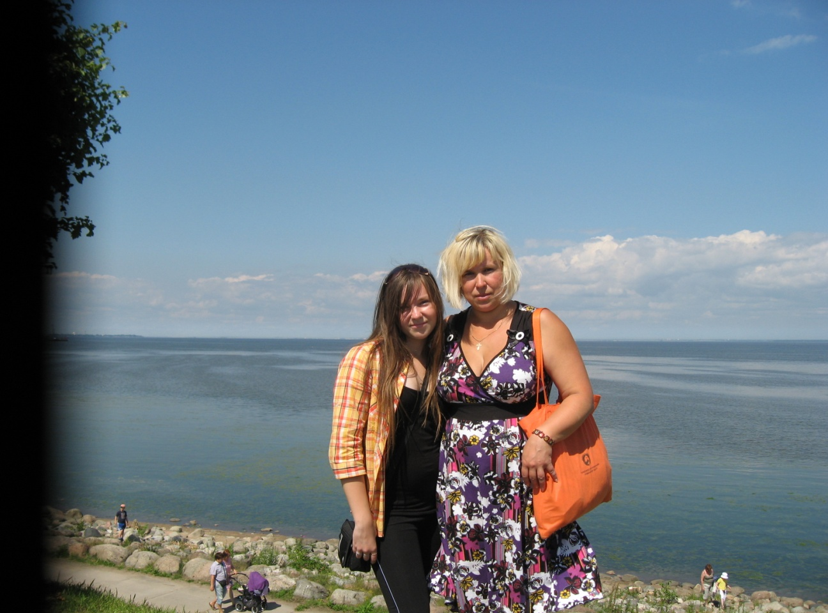
We arrived by car. It took about one day to get there. It’s a very large city, compared with our town. There are a lot of high-rise buildings. But it is strange that I didn’t see enough people on the streets – I think they are all hided in the subway or just at homes. I don’t really know, in our town everybody walks. Never mind. Actually, we arrived in St. Petersburg not to do sightseeing or walk around the town – we came to sail on a motor ship! Our motor ship is called “St. Petersburg”. We sailed on it three days. First, we sailed on the Neva, later we stopped at the amazing place – Valaam Island. It is such a beautiful island that stands on Lake Ladoga. On the way back there were a lot of cute seagulls! I liked them so much that I took some pictures of them. When we got back to St. Petersburg, we did some sightseeing, of course. But not as much as other tourists do, because it wasn’t our intention.
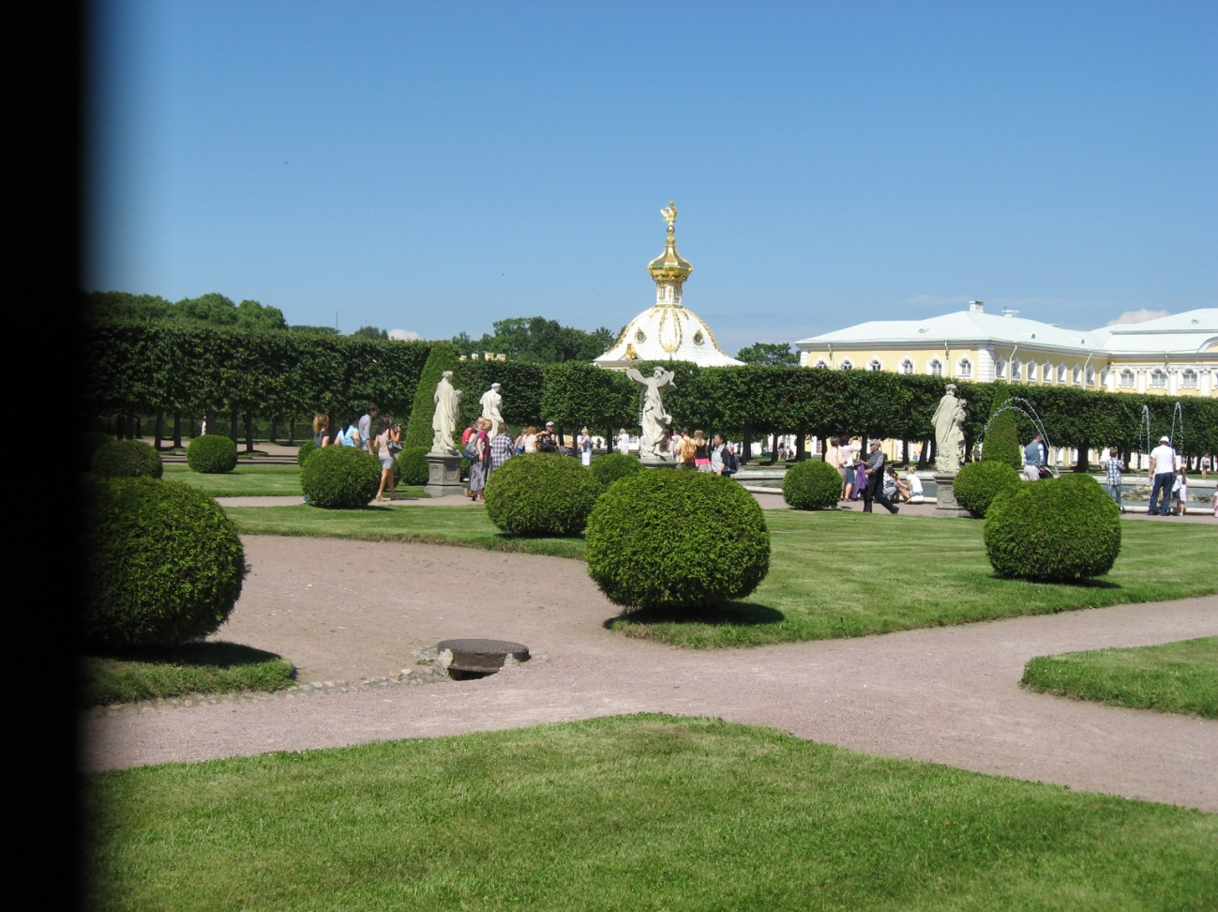
But it is not the end. We decided to visit an awesome place. It is called…Peterhof! There a lot of amazing fountains and royal parks, and one day is not enough to go around them all! We saw only a microscopic part of this place! But it was enough to get an impression for the year ahead. For years ahead…
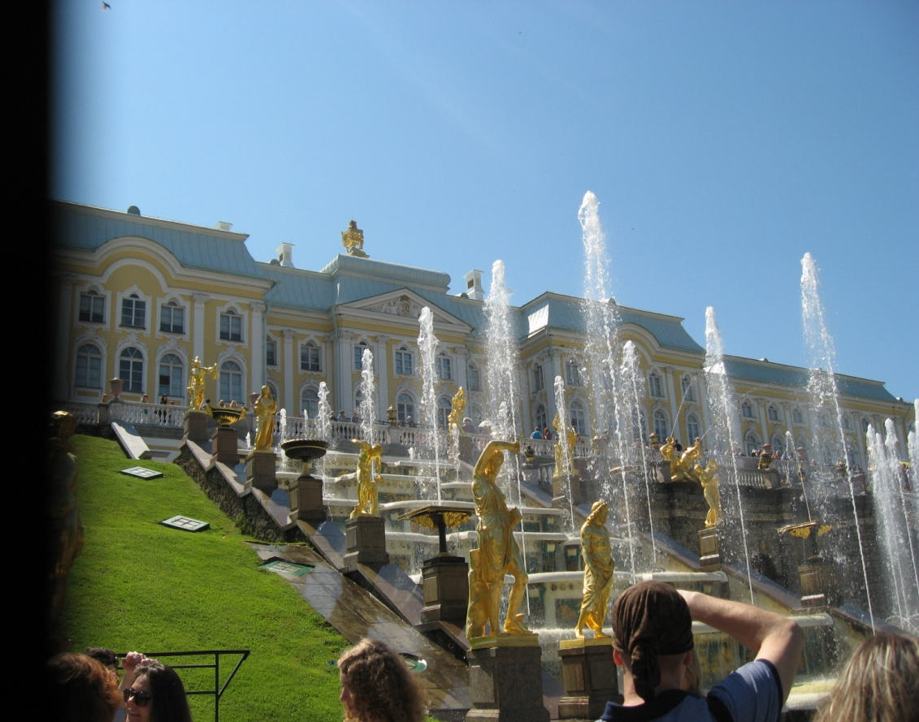
I am still fond of this travelling. We saw a lot of things, got a strong impression that we can never get of books and TV. Years later we will be reminded by the photos of the happy time we have had.
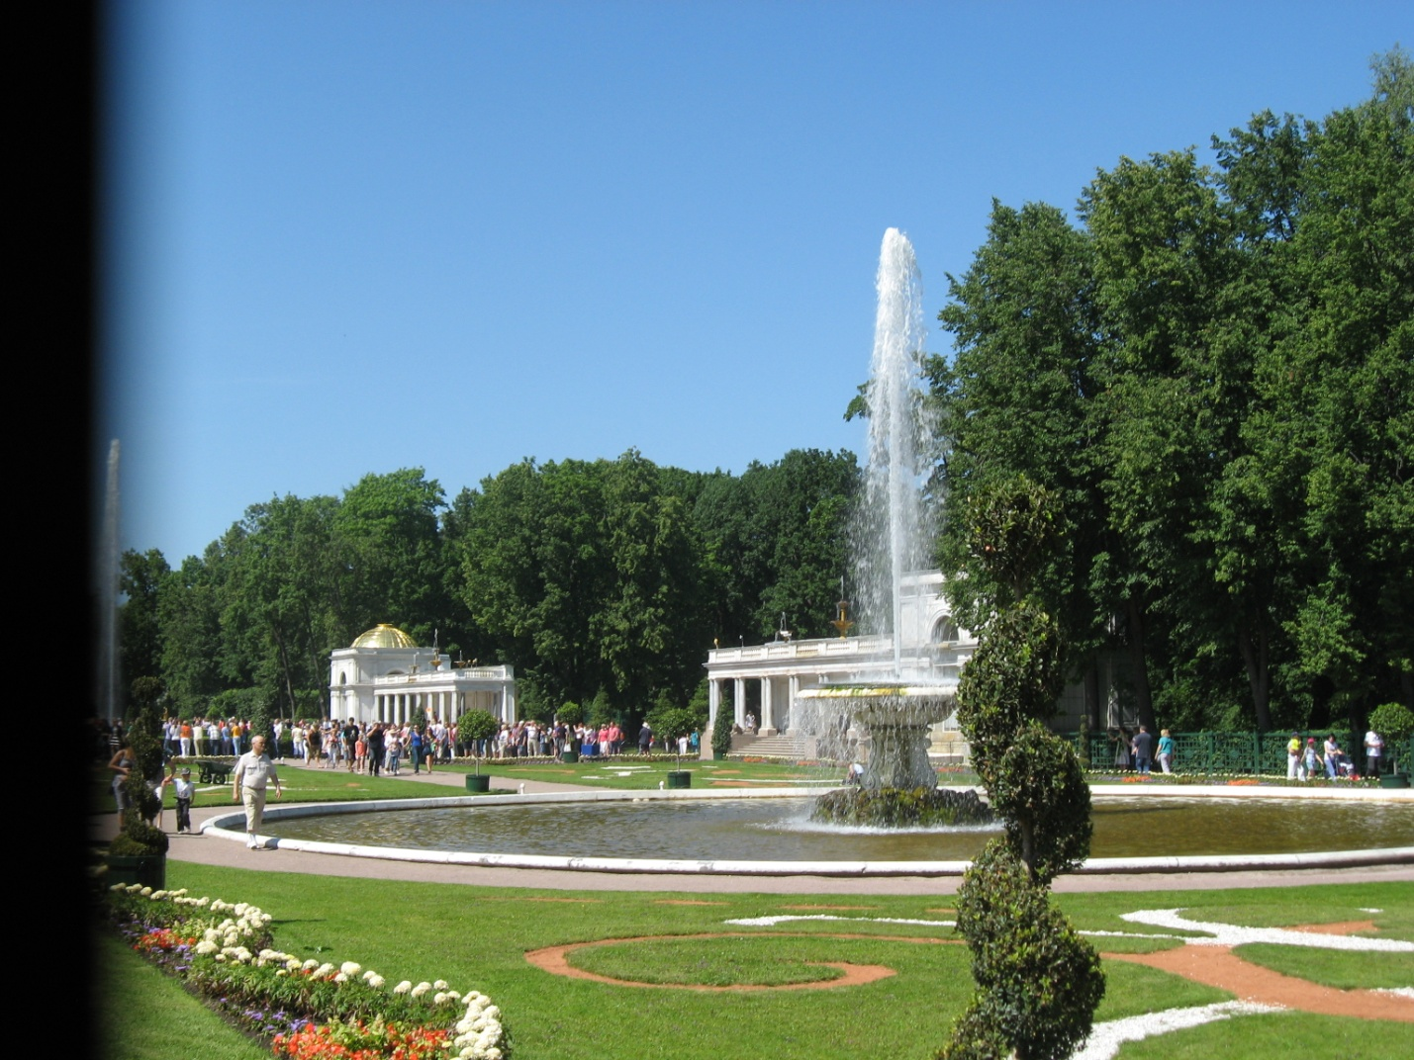

Все фото из личного архива семьи Орловых.
Публикуются с разрешения родителей.

