“My Summer Adventure”

Автор: ученик 6 класса Виталий Ушаков
Учитель: Милинчукова Инна Сергеевна
Школа: МАОУ СОШ №70
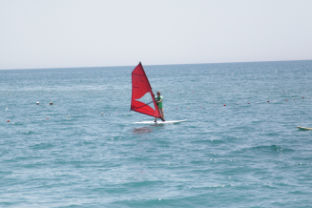Населенный пункт: г. Тюмень
Регион: Тюменская обл.

MY SUMMER ADVENTURES

What Is Summer? Summer is light, sea of light! It is friends, sun and warm wind… And sincerely, It is holiday!
But on my holiday I have been to Turkey. I swam in the tender Mediterranean Sea and glass water shyly rocked me on waves. The blue sky was above me and the blue sea was under!
Also I did windsurfing and wind blew in my face. I fell into the water many times. But I every time got up and learned from it!
I went to Israel in the end of my trip to Turkey. That was a nice adventure! I saw majestic palaces, the place of pilgrimage and even famous Wailing Wall in the Jerusalem! There are many icons in Jesus Christ’s place of birth and it smelled wax. And faith, a lot of faith was in the air!
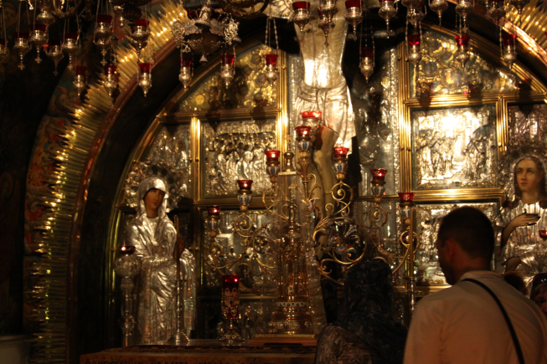 Jesus’ place of resurrection was the most beautiful of all temples I have ever seen! The beneficial fire was lit on the gold wall of this palace and icons revived in this light!
When I flew to my hotel a strong thunderstorm started. Lightings shone around. It felt terribly and wonderfully!
I went to rafting too. I boated on a mountain river. One time my boat turned over and I with my mom fell into cold water. About a minute I fought over then rescuer helped me! I was wet, but happy!
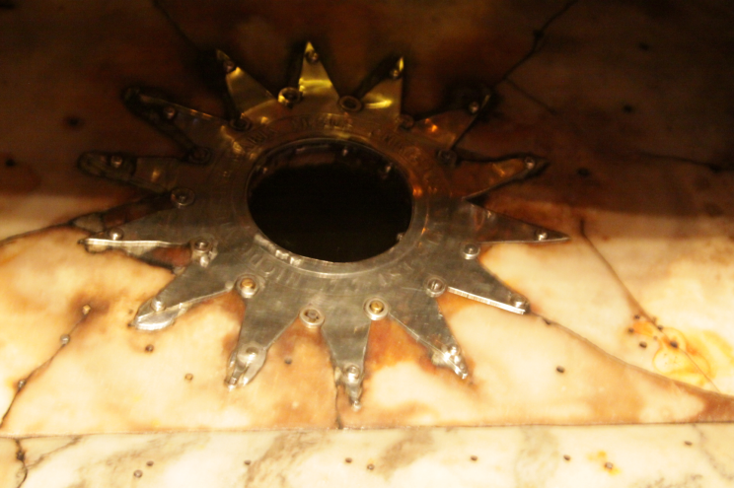What is summer? Summer is happiness. Summer is trips. And sincerely, summer is adventures! But all adventures have a final. And my story is finishing now too!

JESUS’SPLACE OF BIRTH

Фотографии из личного архива размещены с разрешения родителей

