«My Summer Adventure»

Автор: Ахметшина Гульназ 11 класс
Учитель: Нямукова Алла Валерьевна

Школа: № 9

Населённый пункт: г.Бирск

Регион: Республика Башкортостан

My summer Adventure.
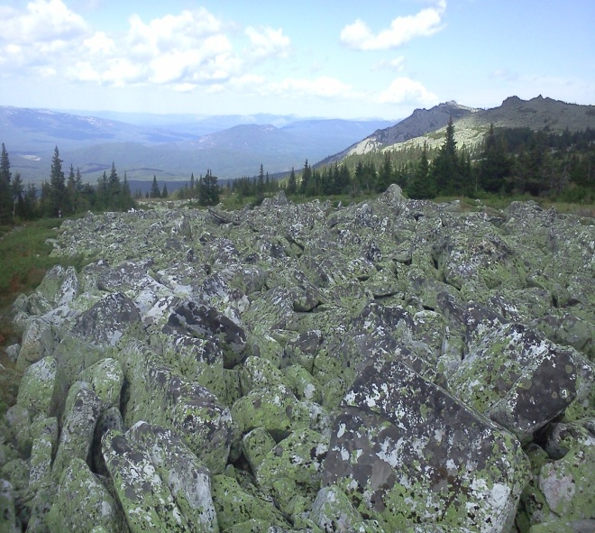 What a lovely season summer is! Everything is in blossom! The flowers are so nice and bright! I personally prefer summer to all other seasons as the weather is warm and sunny. It seldom rains. You can do whatever you like. I had a good time this summer. I went for a walk, read books, watched TV, played computer games, visited my friends and relatives in other cities. I met new good friends and we had a nice time together, playing volleyball, going to the river and what not. I neither studied Maths nor History, though I need these subjects to pass my future exams. So I did nothing useful.
I want to tell you about my summer adventure. But I remember an ascent on Iremel most of all. Iremel is the second highest peak of the Ural mountains, Its height is 1,5 km above the sea level. Iremel is named the Sacred Mountain, because all people, who have been on this mountain, feel incredible enthusiasm and energy of forces and the improvement of their health. The legend says that if you tie a bright ribbon on the Tree of Wishes, it will certainly come true.
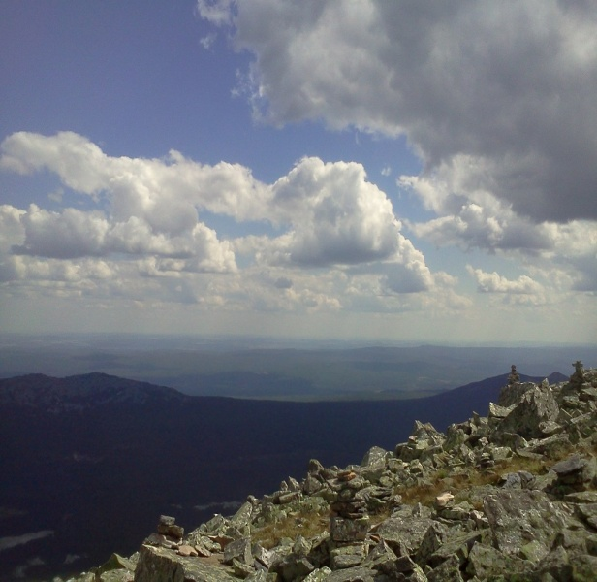
But the climbing to the top of the mountain is a very hard job, because it is necessary to go on foot for about 15 km and 15 km back, so not everyone can endure 6 hours of walking. Besides, the mountain will not allow those people, who go with bad intentions to go to itself and it can organize different obstacles to them. It may suddenly be rainy, wet and foggy or a rude person can get lost there and he won’t be able to find the way back. Fortunately, we managed to climb to
the top without any difficulties, though it was not very easy. On the other hand, the result is worth our spent forces. What a splendid and stunning view on the top of the mountain! 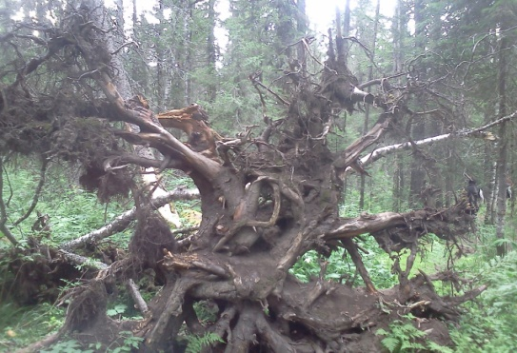 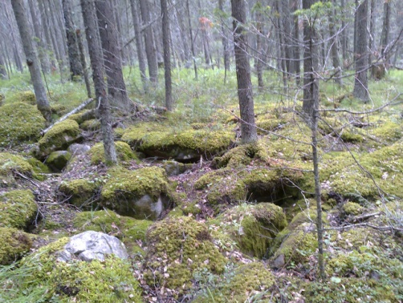
Look at these pictures! Here you can see the forest that resembles a fairy-tale world, far from civilization, there is an atmosphere of fairy- tales and the magic, the terms of centuries-old trees, the roots, the earth, covered with moss, like houses… The impression you get here is like that you are in another world, in another reality. EE
Several times we also went through the mountain river. They say that the water has healing properties; it heals people, rejuvenates and improves their health. 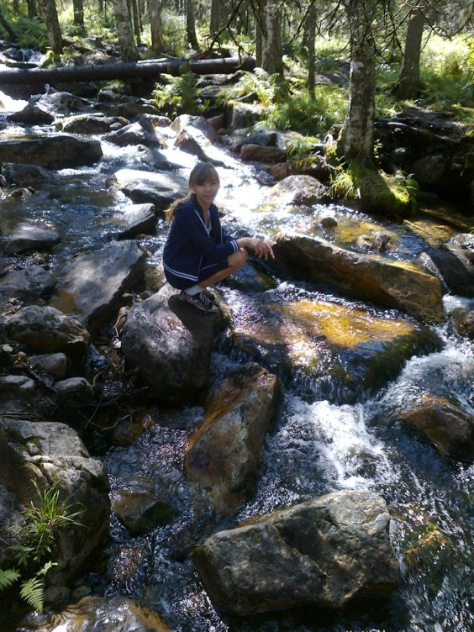More than that, people become stronger and younger having had a swallow of water out of this river. My family and I tried this water too and we were really astonished by its taste.

While we travelling we met many other tourists and made the acquaintance with them. We were really surprised to meet tourists from Germany and Finland. They told us that this mountain is also popular among them.
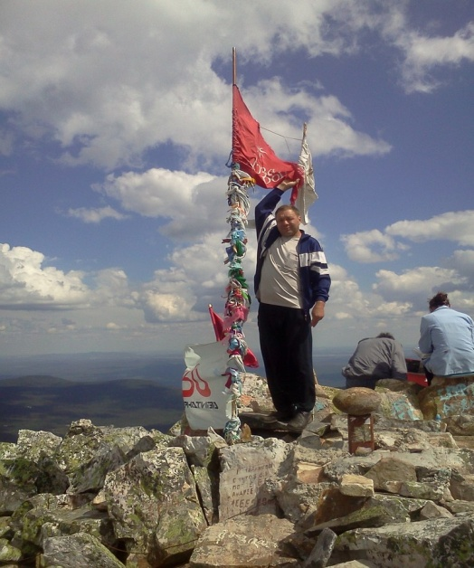
To sum it up, I would like to tell you, that I like this place very much; I feel spiritual calmness and enthusiasm. I want to come back there again and again.
Все фотографии взяты из личного архива семьи Ахметшиных. Фотографии публикуются с согласия родителей.

