My summer adventure.

Автор: ученица 8 класса
Запромётова Мария

Школа : МАОУ ”Лицей № 3”

Учитель: Суркова Татьяна Юрьевна
Населенный пункт: г. Стерлитамак
Регион: Республика Башкортостан

Hi Olga,
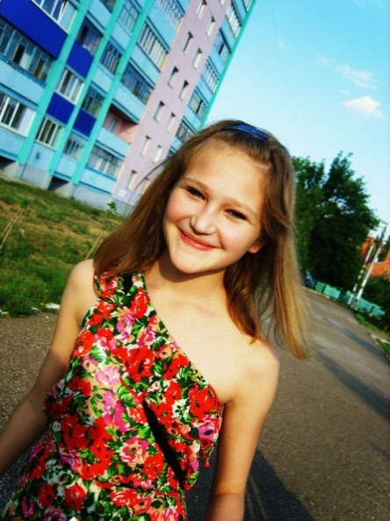
I have not written to you, because I was very busy, but now I have found free time. How are you? I hope everything is OK. How was your summer? Let me tell you about my adventures.
In June I stayed at home because my friends have left town. I was alone. Luckily the weather was nice and warm. It was sunny and there were not any clouds in the sky. I went sunbathing and swimming in the river. Sometimes I was playing computer games and watching movies.
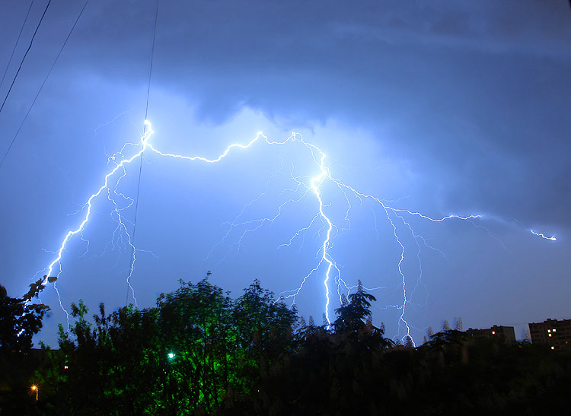
One day my mother sent me to the store. It was warm enough to wear shorts and T-shirt. The store was so far, but I decided to go by foot. I bought something and can go home again. But, when I left the store, the weather has changed. It was cloudy. Light rain was falling across parts of the town. And chances for more rein increased. I thought that I have time to get to the house. But I did not have time - a storm began. Lightning flashed, strong wind was blowing. I got wet. I was scared. It was cold. I fell out a few times along the way, because my shoes were slippery. I came home, but I was sick. I had to drink tablets and lie in bed.
July was the most interesting month. The first two weeks I spent time with my grandparents in the small village. The first time it was unusual. There was no internet, TV – things. Without it I cannot imagine my life, but there were a lot of books. I got up very early and helped my Granny in the big garden. There were many plants there. I really like fresh cucumbers and tomatoes.
The day was hot. I was sitting at home, playing with the cat and read books. In the evening I left the house and walked in the village. I really liked these walks. Light breeze was blowing. It was possible to be alone.
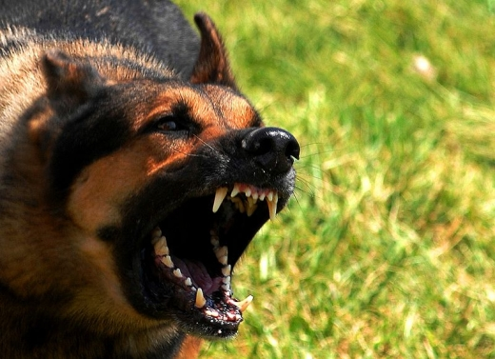
Once I went a long way. I looked all the way at my feet and listened to the birds’ sings. I was surprised at myself when it was dark. The birds did not sing, the dogs were howling somewhere. I did not notice how reached fields - I was very scared. With a cry of freight I turned and ran fleetly. I did not remember where my grandparents’ house. All houses looked identical to me. I heard a dog barking. The sound grew louder.
The dog approached me. I looked round and saw her. It was a big shepherd. She bared her mouth and growled at me. I ran out of my way. My heart was pounding. I wanted to cry. I could not find the strength to run further. The dog caught me up and scratched my legs. I screamed of fear and pain.
I saw a man running towards me. He had a long stick in his hand. I thought he wanted to help me and ran faster. He caught me up, hit the dog and screamed something. The dog whined, stopped and ran away.
- Are you afraid? - asked me the man. Now I could see him well. He was about 30 years old. He was dressed in a work clothes. His hands were soiled from the job.
-Yes, of course, - I answered.
-Are you Ivanova’s granddaughter? I nodded.
-Everyone is looking for you. Your grandmother is worried. Where have you been?
-I…I got lost.
-Let’s go! I'll walk you to your house, - the man said and smiled. We got to the house. My grandmother gave me a hug.
-I was so scared! -she screamed.
-Me too, - I said softly.
-Thank you very much, Victor! - Grandma said the man.
-It's my pleasure.
Grandmother poured me hot tea. I drank it and went to sleep.
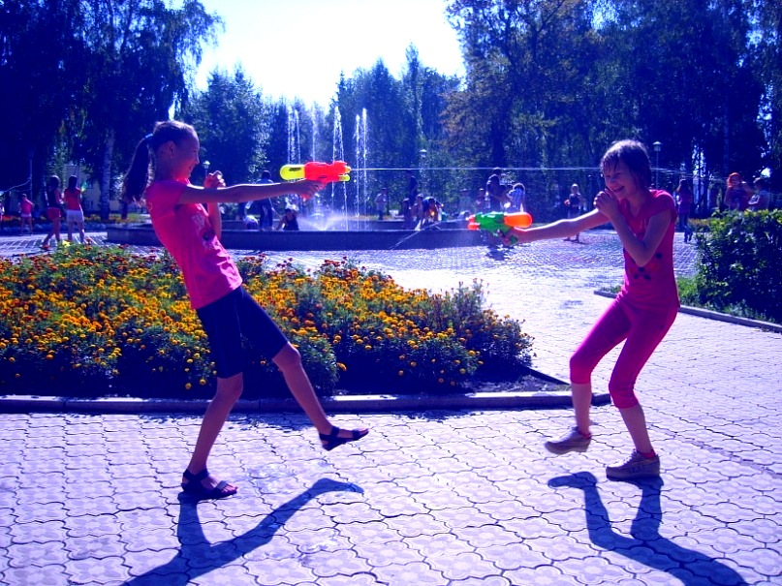
August is the last month of summer, so I was sad. Hot days were less and less. I had to get ready for school. Sometimes I went for a walk with friends. We went to the movies, relaxed in the park and enjoyed the freedom.

I and my friend Laysan decided to go on interesting event in our city - Water Battle. People had to pour water on each other from a fountain with water pistols. We had a lot of fun.
That's how I spent this summer…
Give my regards to your mum and dad! Write me or Skype me soon!
With Love,
Masha
end

https://encrypted-tbn3.google.com/images?q=tbn:ANd9GcTkw4olNgFmZmaxz27cNp5r5oI9XVFAVZfk0I6hQ99MVAuHdVsJsQ
https://encrypted-tbn2.google.com/images?q=tbn:ANd9GcRPSjKGq_XklHCM7ARZ6sP0pT_uUhqPu-JTaSUPD-JYnjdoZZ2f
Другие фото взяты из личного архива

