“My Summer Adventure”

Автор: ученик 9 класса Ситишкин Денис
Учитель: Синякина Ирина Арсентьевна
Школа: МОБУ Талаканская СОШ №6
Населенный пункт: пгт. Талакан
Регион: Бурейский район Амурская область

My summer holidays
For some people there is nothing as exciting as traveling, and I’m not an exception. And I’m happy that I have traveled a lot and I hope that my journey in this summer wasn’t the last one.
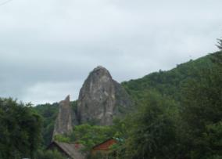
It was the best summer in my life, because I was at the seaside of the Japan Sea. As matter of fact, I was at the sea twice. My first summer adventure was in the end of July. I spent it with the group of guys from our school. They were my classmates, guys from the 8th and the 9th forms. We went 14 hours by train and 5 hours by the car to our wonderful place near Vladivostok. During the way we could see beautiful landscapes. There were three groups from different regions of Russia: from Amur Region, Kamchatka and Khabarovsk.
We got acquainted with them.

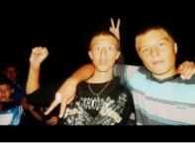
And Nikolai became my new friend. They told us adout there culture, interests and school life.
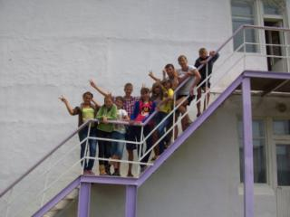
I had had exciting time with them, but I did not remember about my group.

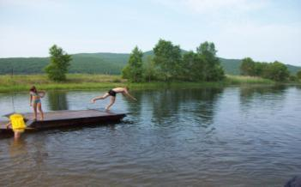

There was a smart lake near our place and we went to it to bathe and swim when the weather was hot.

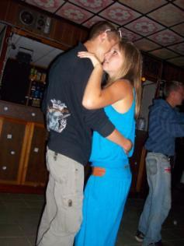
We had cool breakfast, lunch and supper. When I came here I said ‘’Good buy, healthy meals!’’ At evening we went to the disco club, where I danced with the girl from my class.
All together we played cards and ‘’MAFYA”, watched TV-programs, just walk, and listened music. At night we told horror stories and after that nobody could sleep. Sometimes we had competitions between groups. We played table-tennis, volleyball.
But the sea was the best in this rest. Our company was there from morning till evening. Each day was full of small joys. We swam in the sea, lay in the sun, played different games and had a wonderful time. We lived there for about 15 days and did not even notice when the time came for us to return home. The time flew very quickly. It was a wonderful rest. There we went to the hill and saw attractive landscapes, that I never forget. One day we had been invited to the cafe. It was super because I got so much adrenaline. It was strong feeling of horror, but very interesting. There were snakes and bats and spiders. And we tried to eat them. But everybody stayed healthy and fun.
But summer was not forever, and the day came, when we should come back home. It was hard time, but we could not do anything. And we promised to return here next summer.
My second adventure began in the end of August. But this rest I spent with my parents and our family`s friends. We went to the seaside too. Second rest was not worse than the first one. We lived in tents. And it was cool! The sea was 50 meters from our tents. There were strong waves and fresh air. Every day I caught seashells and small fishes. One day we went to Nahodka, where we visited many museums. It was so interesting! I saw pictures, sculptures, maps and guns. It was so important for me as I like history. Now I can tell my friends more about wars between Russia and Japan. We visited the hill, where Russian soldiers were buried after wars. And we could see strange lights on that hill.
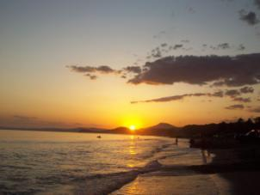
At last day of my second travel, we were surprised by such beautiful sunset. It was the best summer in my life.

Фотографии взяты из семейного альбома семьи Ситишкиных. Фотографии публикуются с разрешения родителей.

