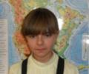
“My Summer Adventure”
Автор: ученица 7 класса
Купреева Алёна
Учитель: Синякина Ирина Арсентьевна
школа: МОБУ Талаканская СОШ № 6
Населенный пункт: пгт. Талакан
Бурейский район
Амурская область

My name is Alena, I`m a student of the 7th form.
I had a good summer holidays this year. And now
I want to tell you about my rest time during my summer.
The school year was over and I could do that I want.
But my parents decided to send me to my aunt Nelly,
where I had to help her. At the beginning I was angry,
but my adventures were waiting me in the future. I went
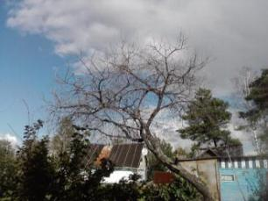
to the village Rodionovka.
It is a small village with a
wonderful forest and the river
Bureya near it. At the beginning
I didn’t feel myself well, because I thought it would be boring.
But in the second day I got
acquainted with a boy and his
sister Lena.

Boris and Lena were children of my age from
Blagoveschensk. We had a lot of fun together.
We spoke a lot of time about everything in the
world. We had very many interesting events and much
interesting times. Sometimes we took part in the
competitions or games with other children. At night my
friends and I went to the disco. But it was very seldom.
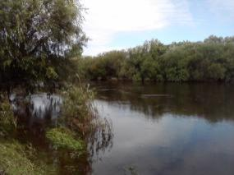
We spend our time near
the river, where we swam
and fished, listened music.
It was the best time in my
life, because I learned to
ride a horse.

Sometimes I made a fire with my friends at the river
and cooked potatoes there. It was wonderful.
We told anecdotes to each other, and did everything
we wanted. I also got used to walk alone in the forest.
When the weather was rainy we enjoyed watching
cartoons. Personally, I thought we were friendly. We
always helped each other. Now I miss to my friends.
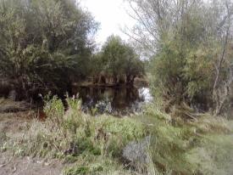
What I was stupid, when I was angry on my parents
in the beginning of the summer. When I came back home,
I asked forgiveness at my parents. I expressed thankful
them for my summer holidays.
Now I can tell my classmates about the best summer holidays
and my new friends .

Ссылки на источники:
http://stat20.privet.ru/lr/0b2e182eecf29fd551e18087524f2a78 - рамка
Фотографии несовершеннолетнего публикуются с разрешения родителей
Фотография из личного архива семьи Купреевых

