«My summer Adventure.»

Автор: ученик 5 «А» класса
Зырянов Алексей
Учитель: Угач Людмила Николаевна
Школа: МБОУ «СОШ № 18»
Населённый пункт: город Ачинск
Регион: Красноярский край

2012-2013.
I like summer very much because I can swim and dive in the river; I can play with my friends and I like fishing together with my dad and grandpa.
This summer was rather hot and sunny. It was a good time for fishing. I and my dad always went to the river called Chulym. People say the Chulym was rich of fish some years ago. But nowadays we also catch some fish for our dinner.
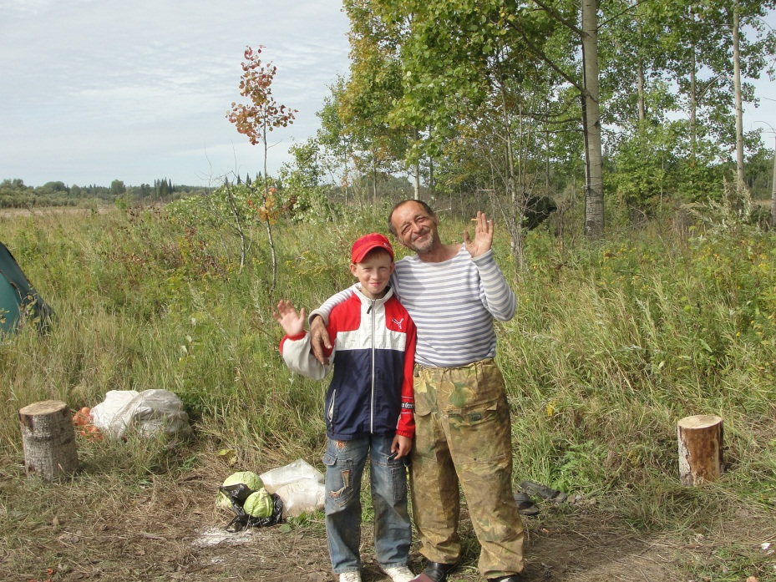
One day we took several dad’s friends with us. We all decided to sit into our rubber boat. The boat can put up one hundred and twenty kilograms, but six men are mare then three hundred kilograms. When we were far from the bank the boat began to sink. We were afraid. We didn’t want all our fish throw out. We didn’t want to be in the cold morning water too.
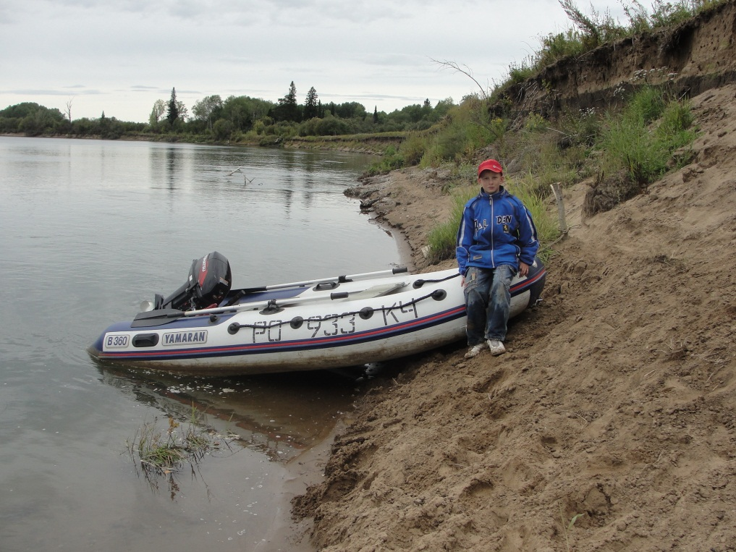

We were wet. But my dad repaired the boat’s motor and we landed to the bank. Of course everything ended happily. But everybody was wet up thread. We were cold. My grandpa made a fire quickly.
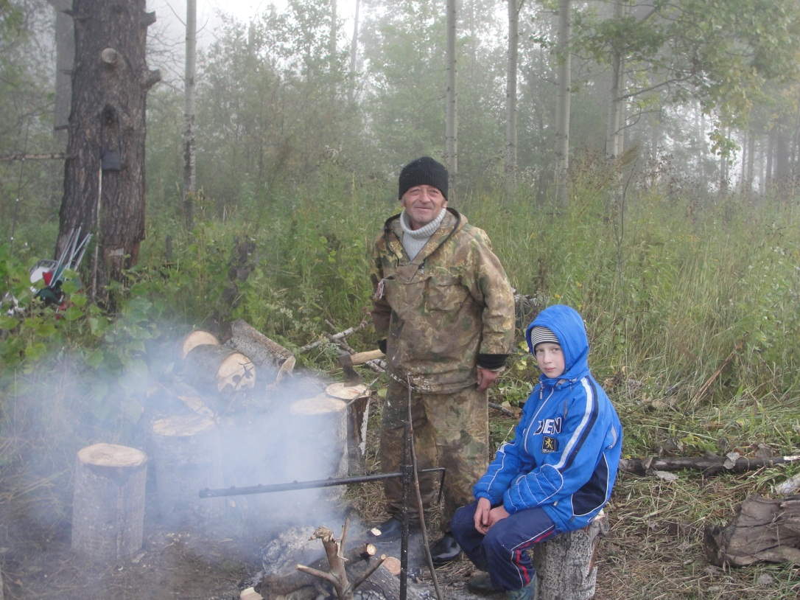
We dried and then return at home. That was the end of my fishing. But as real a fishing man I can tell you lot of fishing stories.
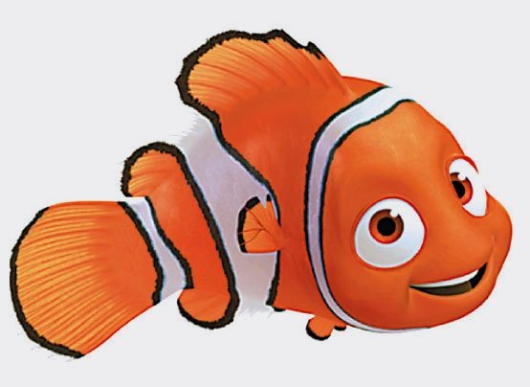

Фото из личного архива автора: Зырянова Алексея
Все фотографии несовершеннолетних опубликованы с согласия их родителей.
Ссылка на картинку:
http://raskrashkirus.ru/malenkie-kartinki-dlya-detey.html

