

**“My Summer Adventure”**

**Автор: ученик 5 класса Фисенко Никита .**

**Учитель: Баева Татьяна Викторовна**

**Школа: МБОУ СОШ № 4 с углублённым изучением отдельных предметов**

**Населенный пункт: г.Батайск**

**Регион: Ростовская область**

I would like to tell you about my summer adventure.

My name is Fisenko Nikita, I am a student of

the 5th form.

This summer I went to the seaside with my family.

On the 19th of August we arrived to Novomikhailovskoye village. There are always a lot of tourists there. This time there were a lot of tourists too.

The first day the sun was bright, the sea was warm and everything was fine. We relaxed, swam, sunbathed.

In the evening of the next day the rain started, something roared and flashed. On the 21st of August it was raining all day long. In the evening the wind sprang up, the sea was stormy, the waves were high. We lived on the 4th floor of the hotel, we didn’t go out of our room because of the weather but we were not bored. We read books; my brother played the guitar for us. At 11 o’clock we went to bed. At 1:00 am my brother woke me and my mother up. He said anxiously: “Something’s happened”. We heard sirens outside, people were running somewhere, children were crying. We decided to find out the situation. We went downstairs to the manager, he said: “The flood”. We went back to our room, took our documents, some water and biscuits, put warm clothes on.

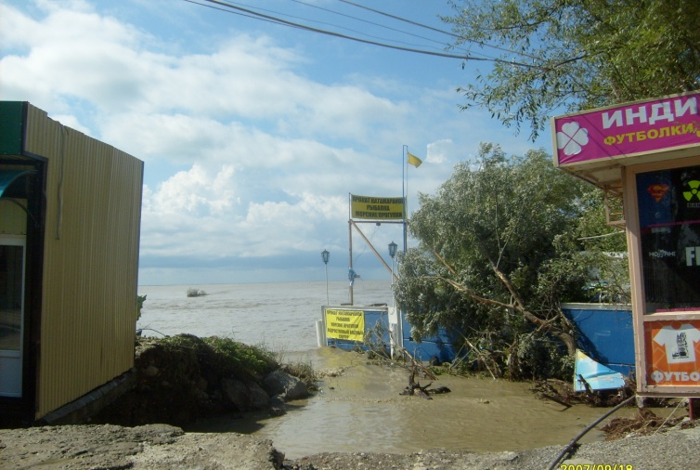Sometime later it became dark, there was no lighting in the village, it was frightful. But we tried to stay calm. Our mother said: “Everything will be OK” . We stayed in our room and could do nothing. We had no place to go, it was raining heavily. We could hear the roar of the mountain river, and it was more and more water. So the water flooded the ground floor of the building we lived. At about 4:00 am it stopped raining and the water began to leave.

We went to sleep. At 7 o’clock in the morning we woke up and went outside.

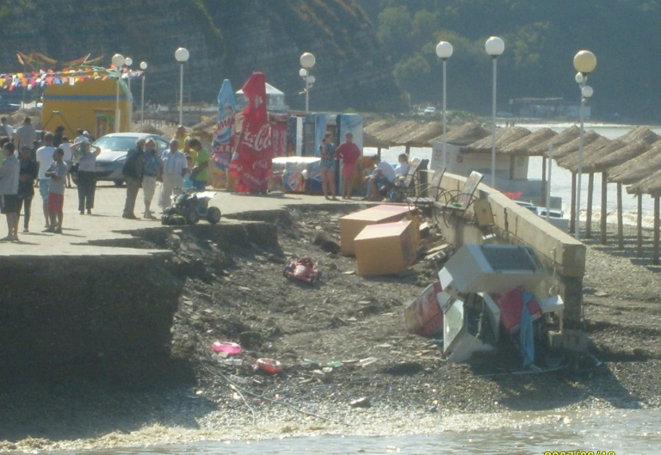There was almost no water, but there was a lot of dirt. In the market near the sea, everything was scattered and overturned.

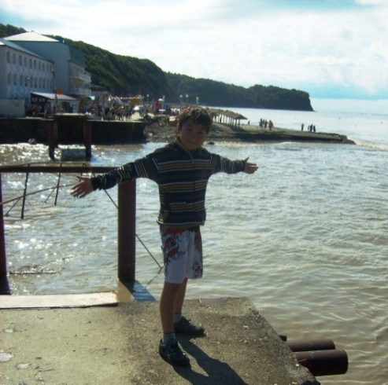The water went away, leaving a lot of destruction, it flooded the cars up to the roof. People tried to fire them up. People took away dirt and put everything into order. The flood destroyed the road along the board of the river Nechipsukho. And it washed a footbridge over the river. We came back to our room in the hotel, packed our bags quickly and went home. In the evening we were safe at home. We couldn’t quiet down at once. But we were lucky, all the family stayed safe and sound.

Thus my summer “adventure” ended.

Фото из личного архива семьи Фисенко. Публикуются с разрешения родителей несовершеннолетнего