

**“My Summer Adventure”**

**Автор: ученица 9 класса**

**Сулейманова Александра**

**Учитель: Непейвода Наталья Владимировна школа: МБОУ «Кузьмичевская» СОШ**

**Населенный пункт: п.Кузьмичи,**

**Городищенский район**

**Регион: Волгоградская область**



My summer adventure.

My summer was excellent!

My name is Alexandra, I live in Kuzmichi. I am 14 years old.

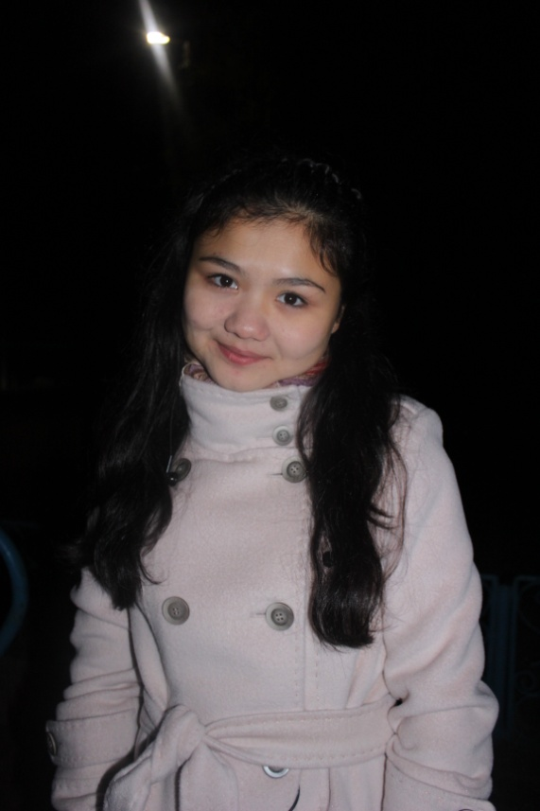

My summer holydays I spent near the sea. And I can say that it was real adventure because I know what will be waited for me but didn`t know that it was so BRILLIANT!

Well, my holydays began very well. In June I was in the Ukraine, near the city Sevastopol, in the Crime. The Crime is wonderful city there are many camps and resort hotels. It was children`s camp. I liked this summer trip to this camp very much because it was very interesting, fascinating, amusingly and funny. Children`s camp it is a place where every child can make new friends, to spend time very well, learn something new. So there were many things which I did. What I did most of the time – I swam in the sea or swimming pool and sunbathed. 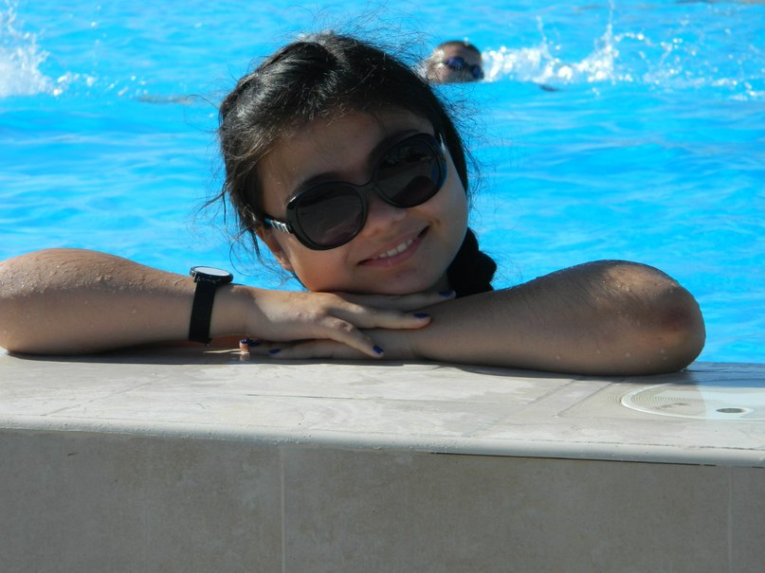

Sometimes our unit took part in the competitions or games. At night my friends and I went to the disco. But it was very seldom. Quite often I went to the football match with boys to Euro 2012. I couldn`t believe to my eyes. Similar we liked to go to the cinema and to watch cartoons. Our unit was very harmonious and friendly. We always helped each other. Finally we made friends and didn`t want to part company. Now I miss to my friends.

I think summer is the best season of all because it is warm, the weather is wonderful and nature is beautiful. Summer is time of holydays. Also summer is a good time for adventures and traveling and great opportunities for memorable rest after whole years of hard work or study. I`m crazy about traveling and feel amusing visiting new places, getting more impressions and knowledge about them.

поппоп



After camp I was home a few days. While I was in the camp I missed for my classmates and native village. I spent a good time in the village with my friends. We went to the cinema and suited parties. Also walked every night. But the most important occupation was a preparation for dancing competition in Bulgaria. We visited workout every day and practiced for several hours a day. In early July we went to Bulgaria city Varna. We got there two and a half days by train. We drove for a long time and watched the nature from the window of the train. We enjoyed the environment, fields, the mountains, new towns. When we arrived we were met by Nicholas. He accompanied us to our hotel. A wonderful four-story building expected us with comfortable rooms, with beautiful gardens. Next day from morning we went to the city, to the beach. The first day was quite. All night my friends and I went for a walk. A few days later we took part in dancing competition. All night we were getting ready for the evening performance. We ironed our suits and were worried. But we were worthy and won the first place. 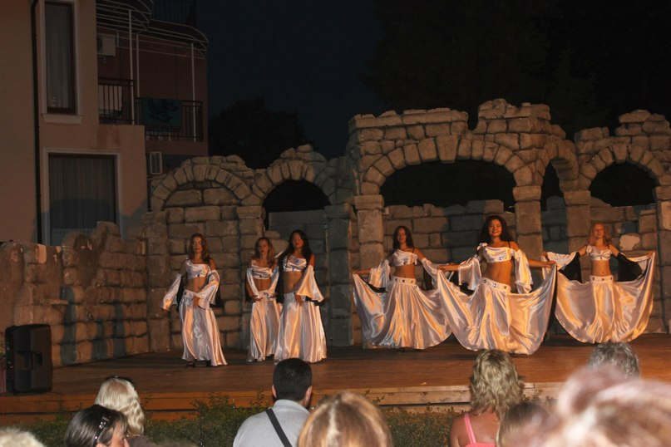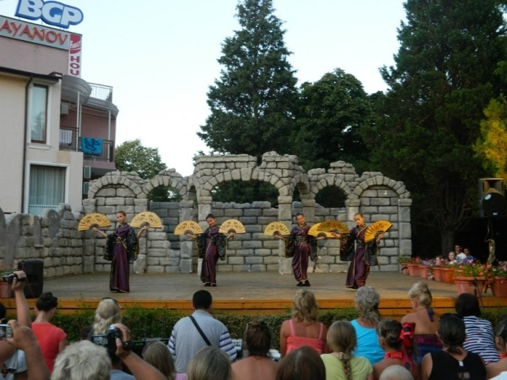

We were very happy and didn`t believe in our victory. Following days we walked around the city and bought souvenirs for family, relatives, and friends. In closing days the weather was spoilt, became colder. It was sadly to say goodbye to the sunny city and friends. At the end we were awarded with certificates and medals for the victory.

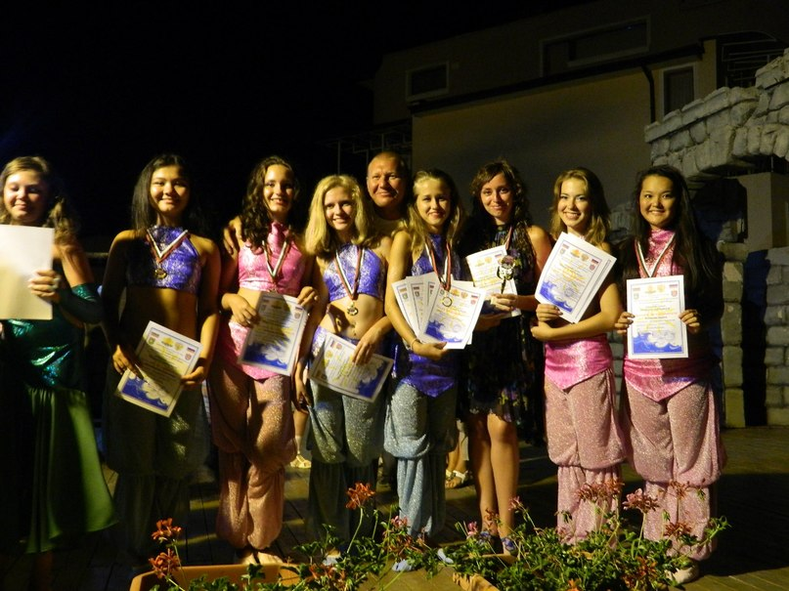



But holydays went to the end and we needed to return home. After Bulgaria I stayed home and spent the biggest part of August sitting and reading books. Of course it was not interesting as a journey to Bulgaria but I had to do it, because I want to get good marks on exams next year. This summer, this adventure, this journey left the wonderful impressions in my heart. And I believe and hope that it is just beginning of my interesting life.

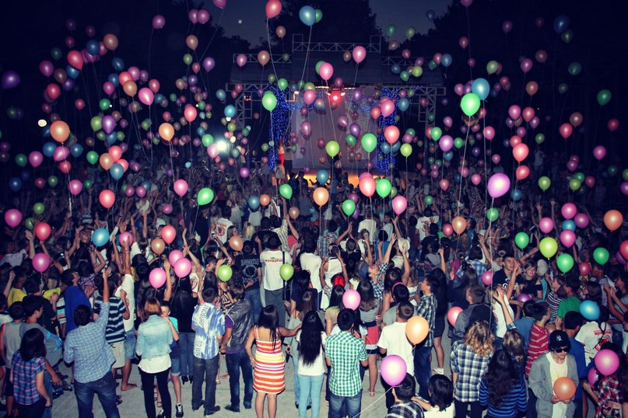



<http://www.design-warez.ru/uploads/posts/2009-05/1242941970_vesenie-nastroenie.jpg> -рамка

фото из личного архива семьи Сулеймановых.